Storage

AWS Solution Architect Associate

# Section 5: EC2 Storage – EBS & EFS

## 55. EBS Intro

## 57. EBS Volume Types Deep Dive

### GP2 – General Purpose SSD

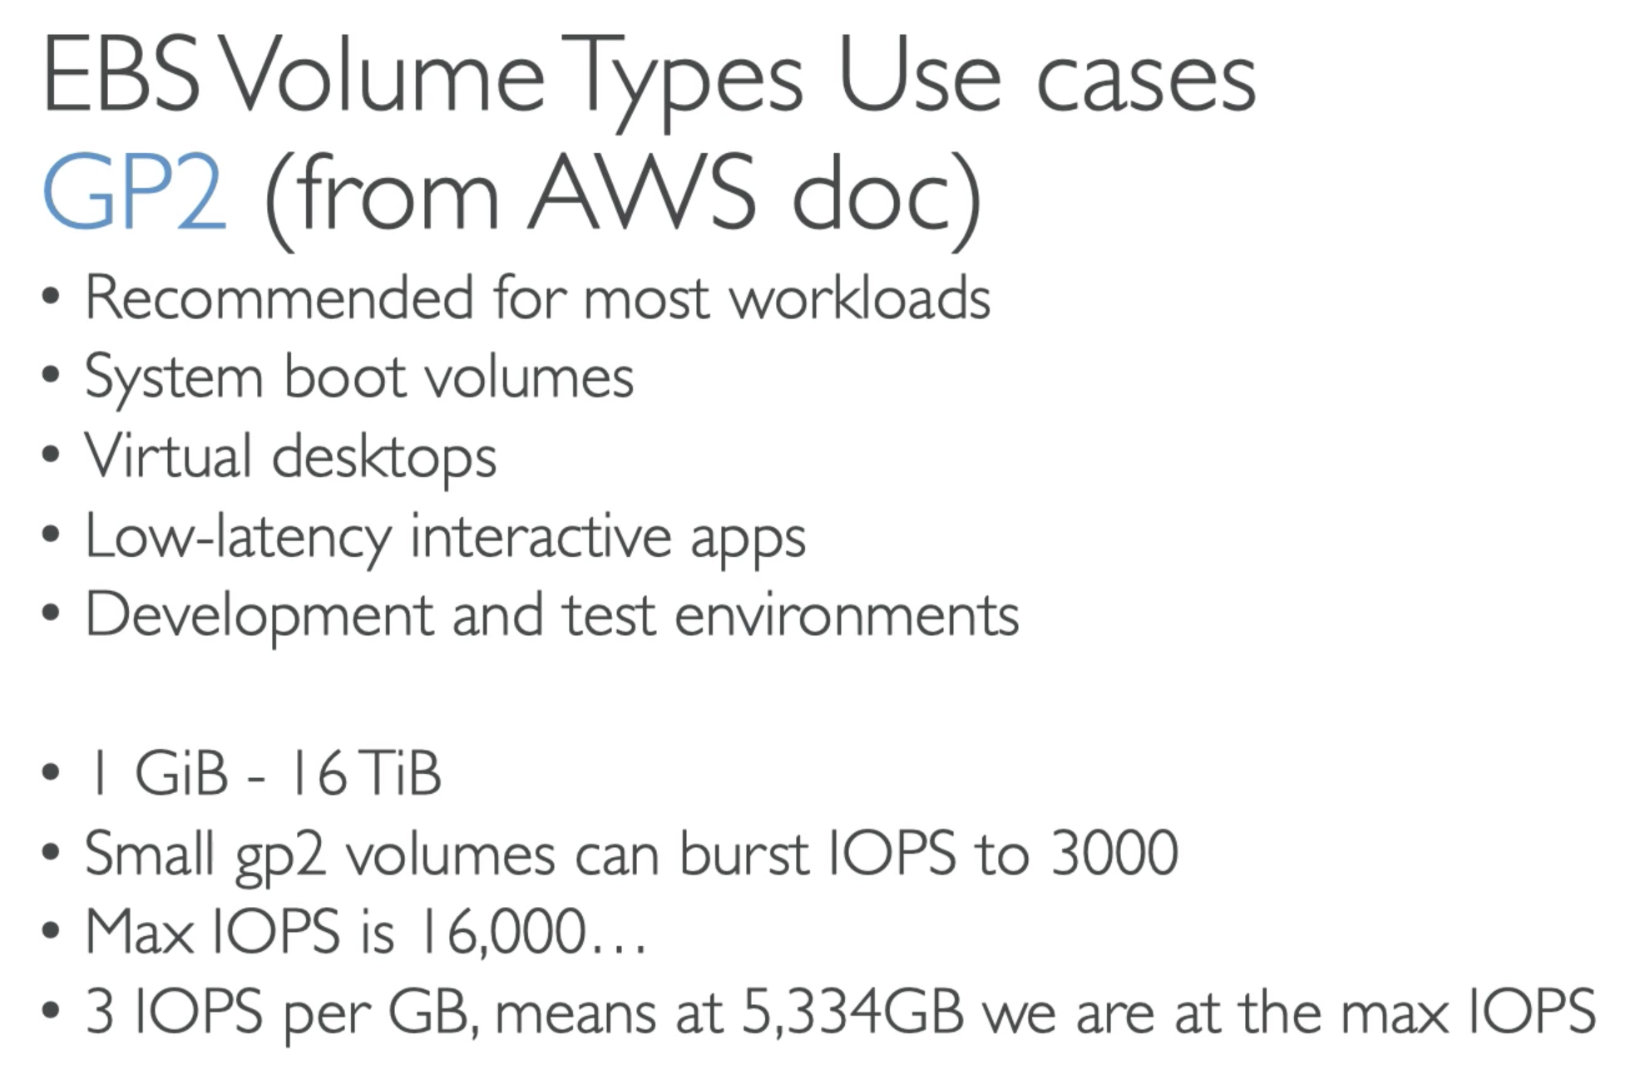

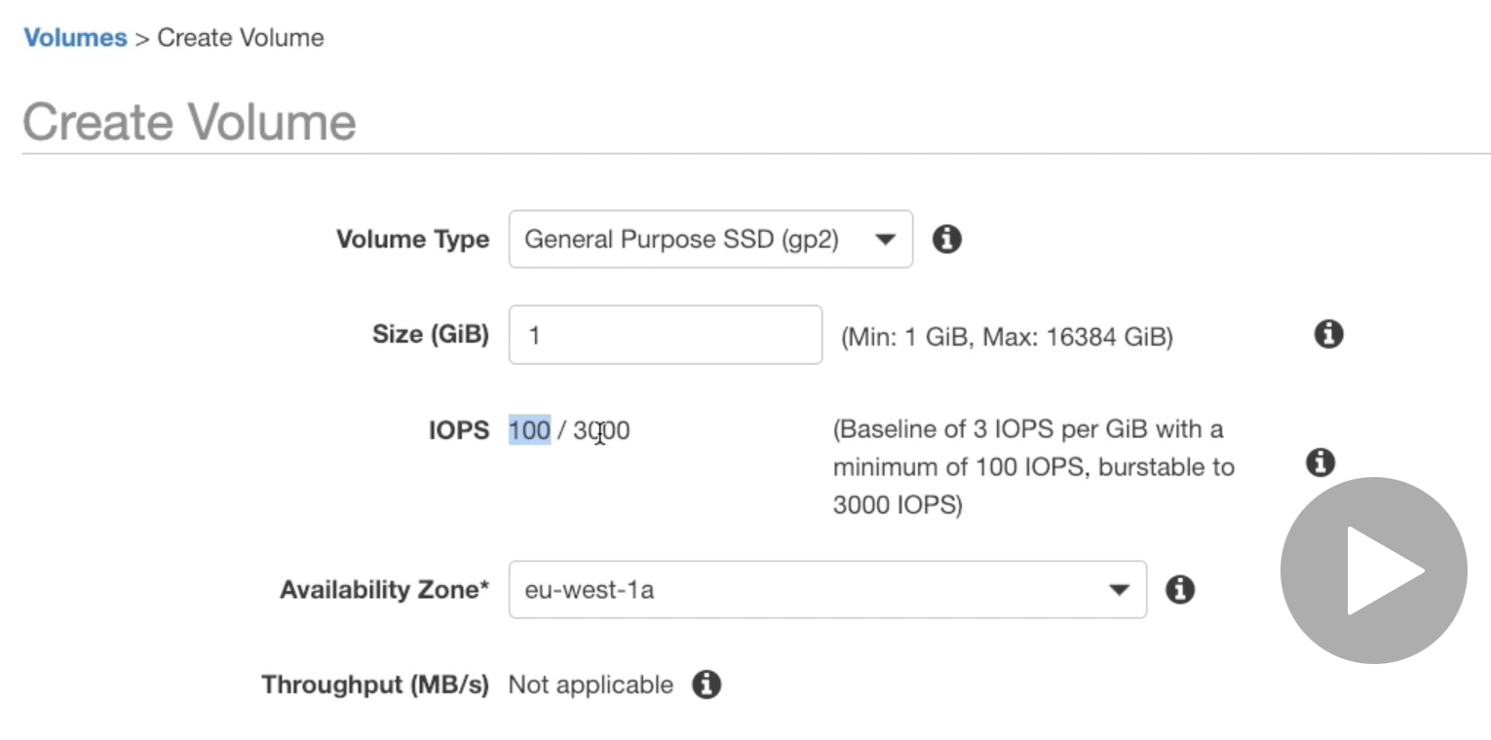

* Volume size and IOPS are related, change the size IOPS will change accordingly
* Baseline of 3 IOPS per GiB with a min of 100 IOPS, burstable to 3000 IOPS…

### IO1 – Provisioned IOPS SSD

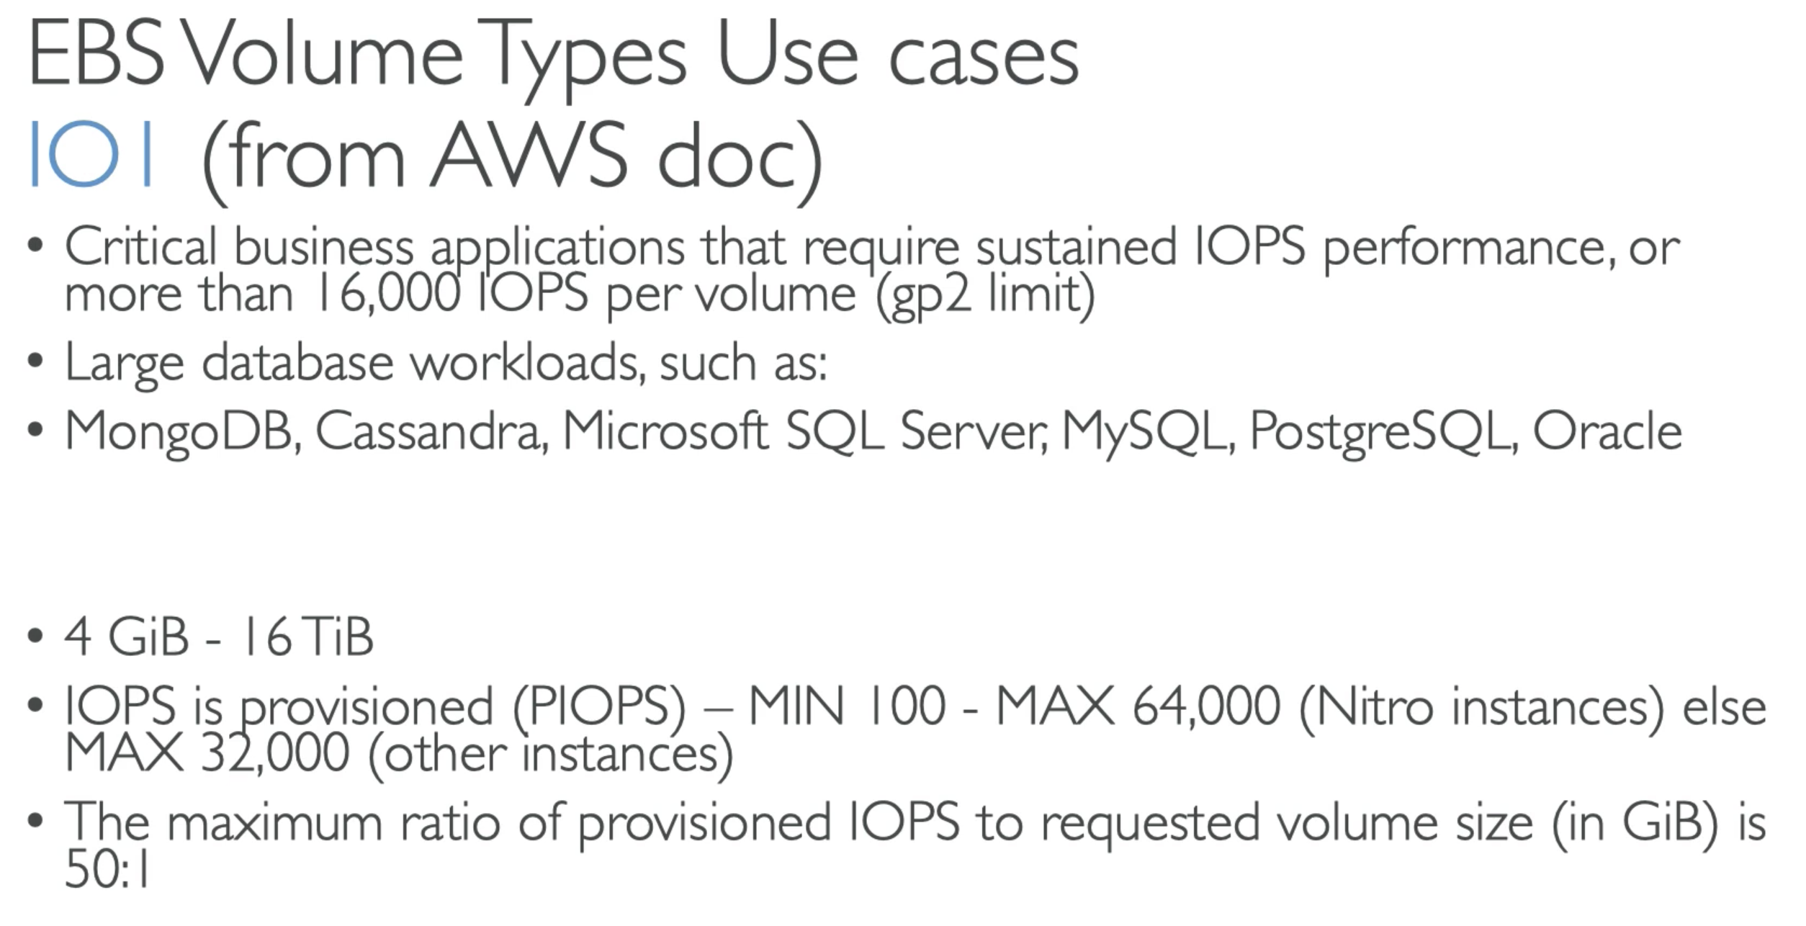

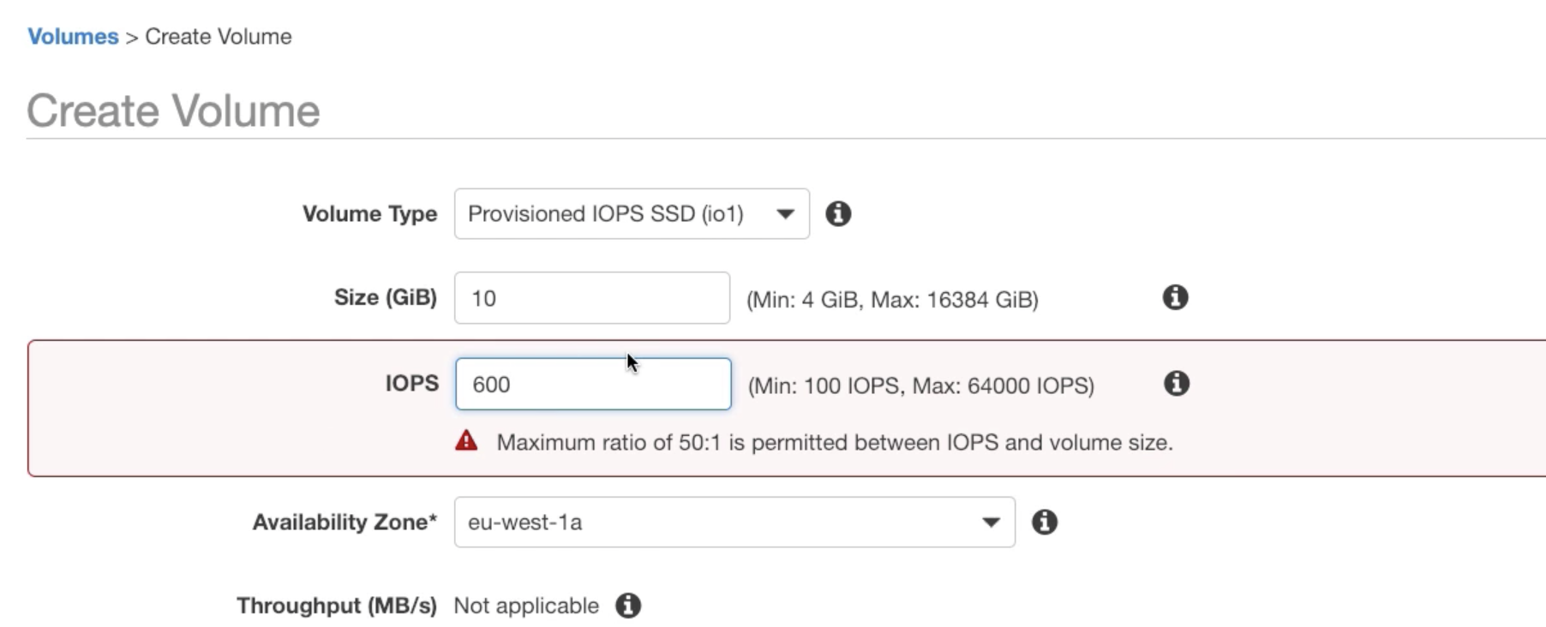

### ST1 – Throughput Optimised HDD

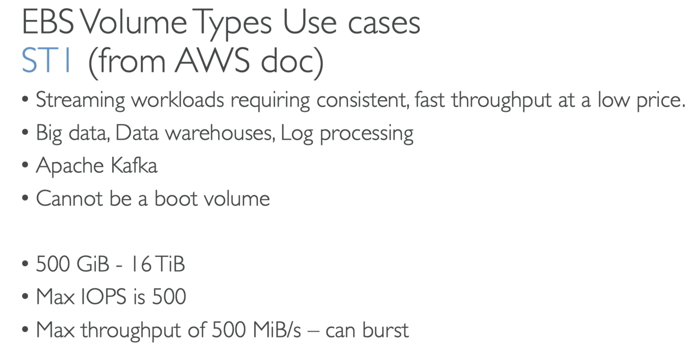

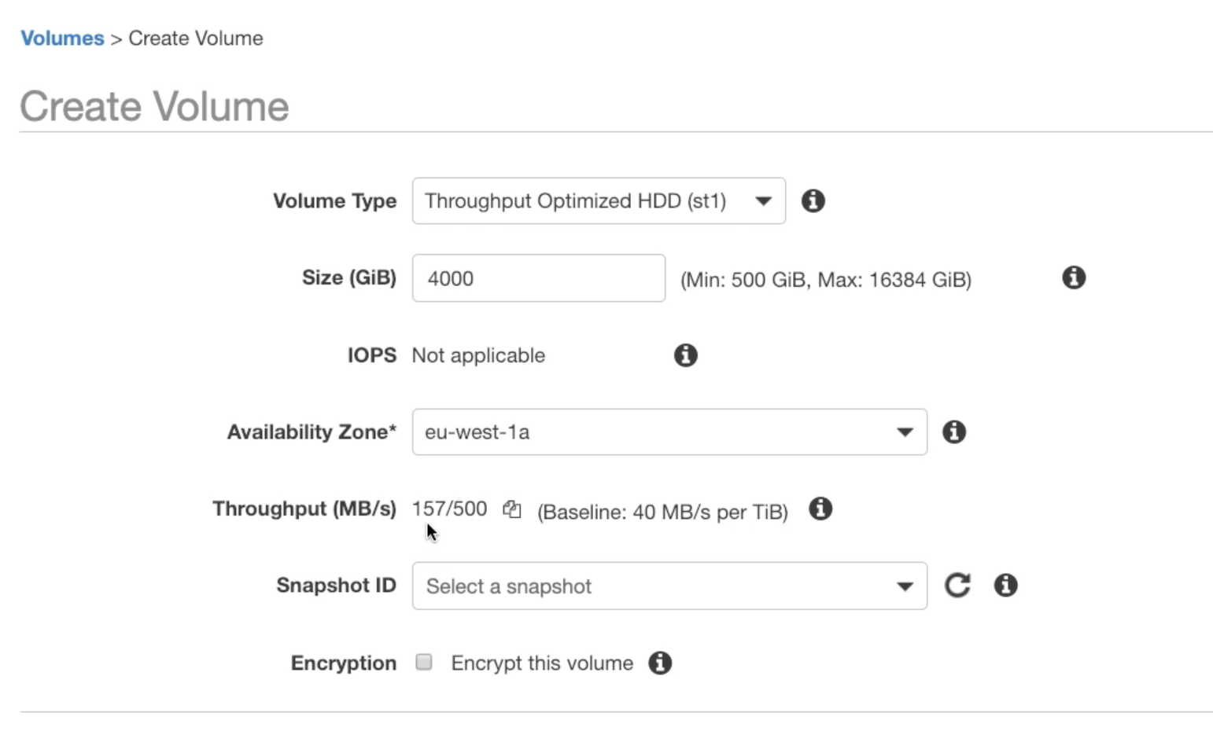

Size and Throughput are related….

### SC1 – Cold HDD

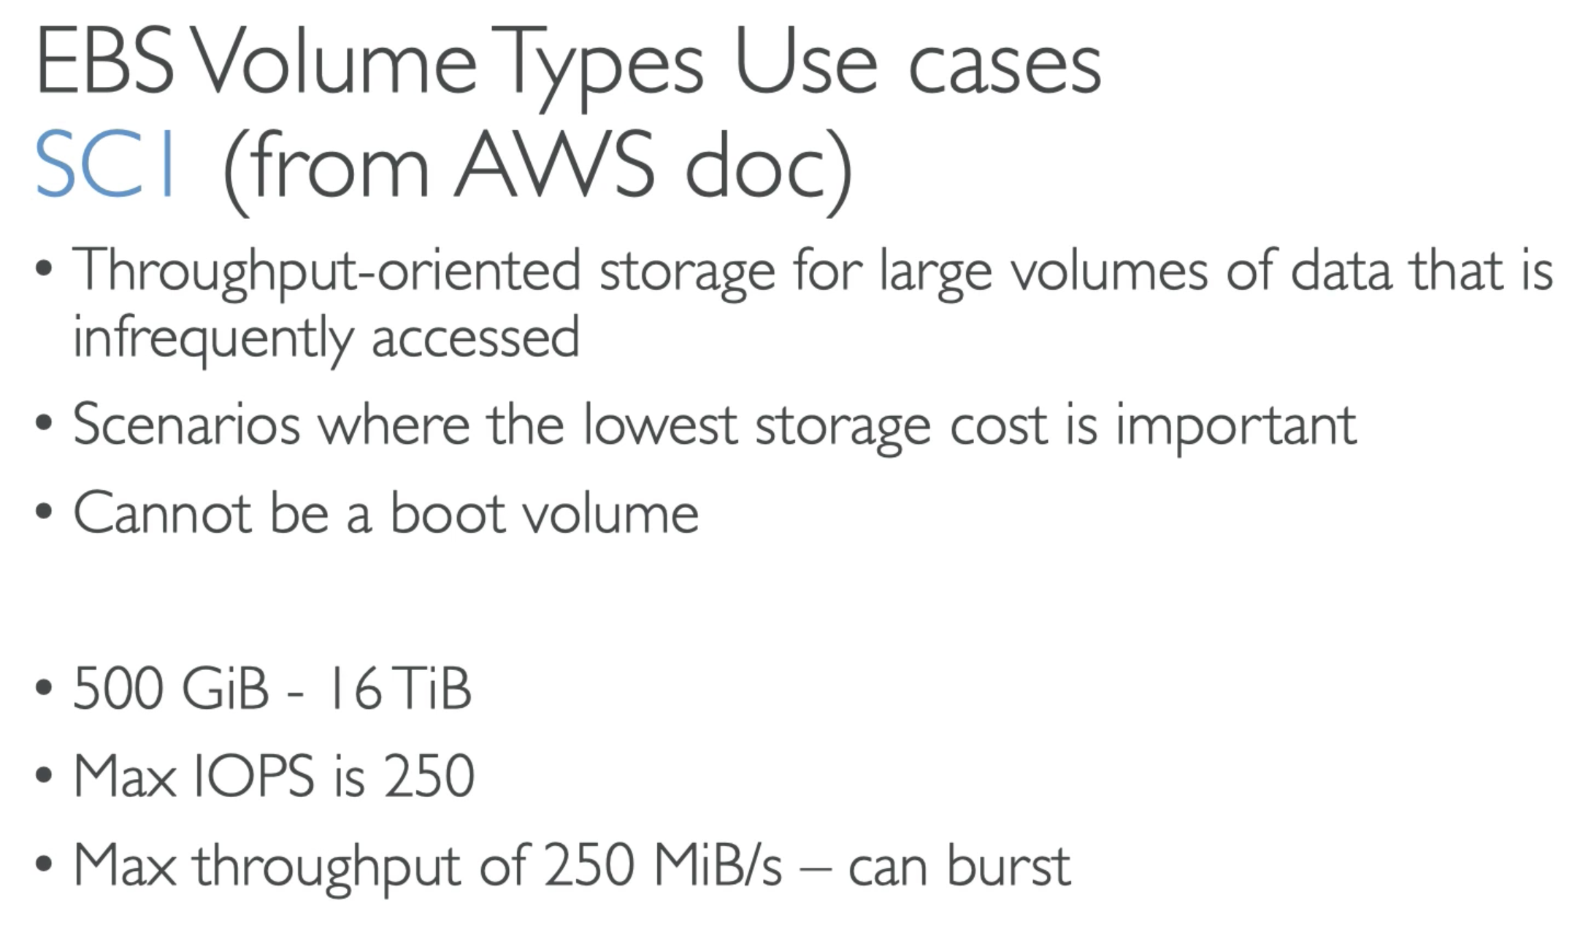

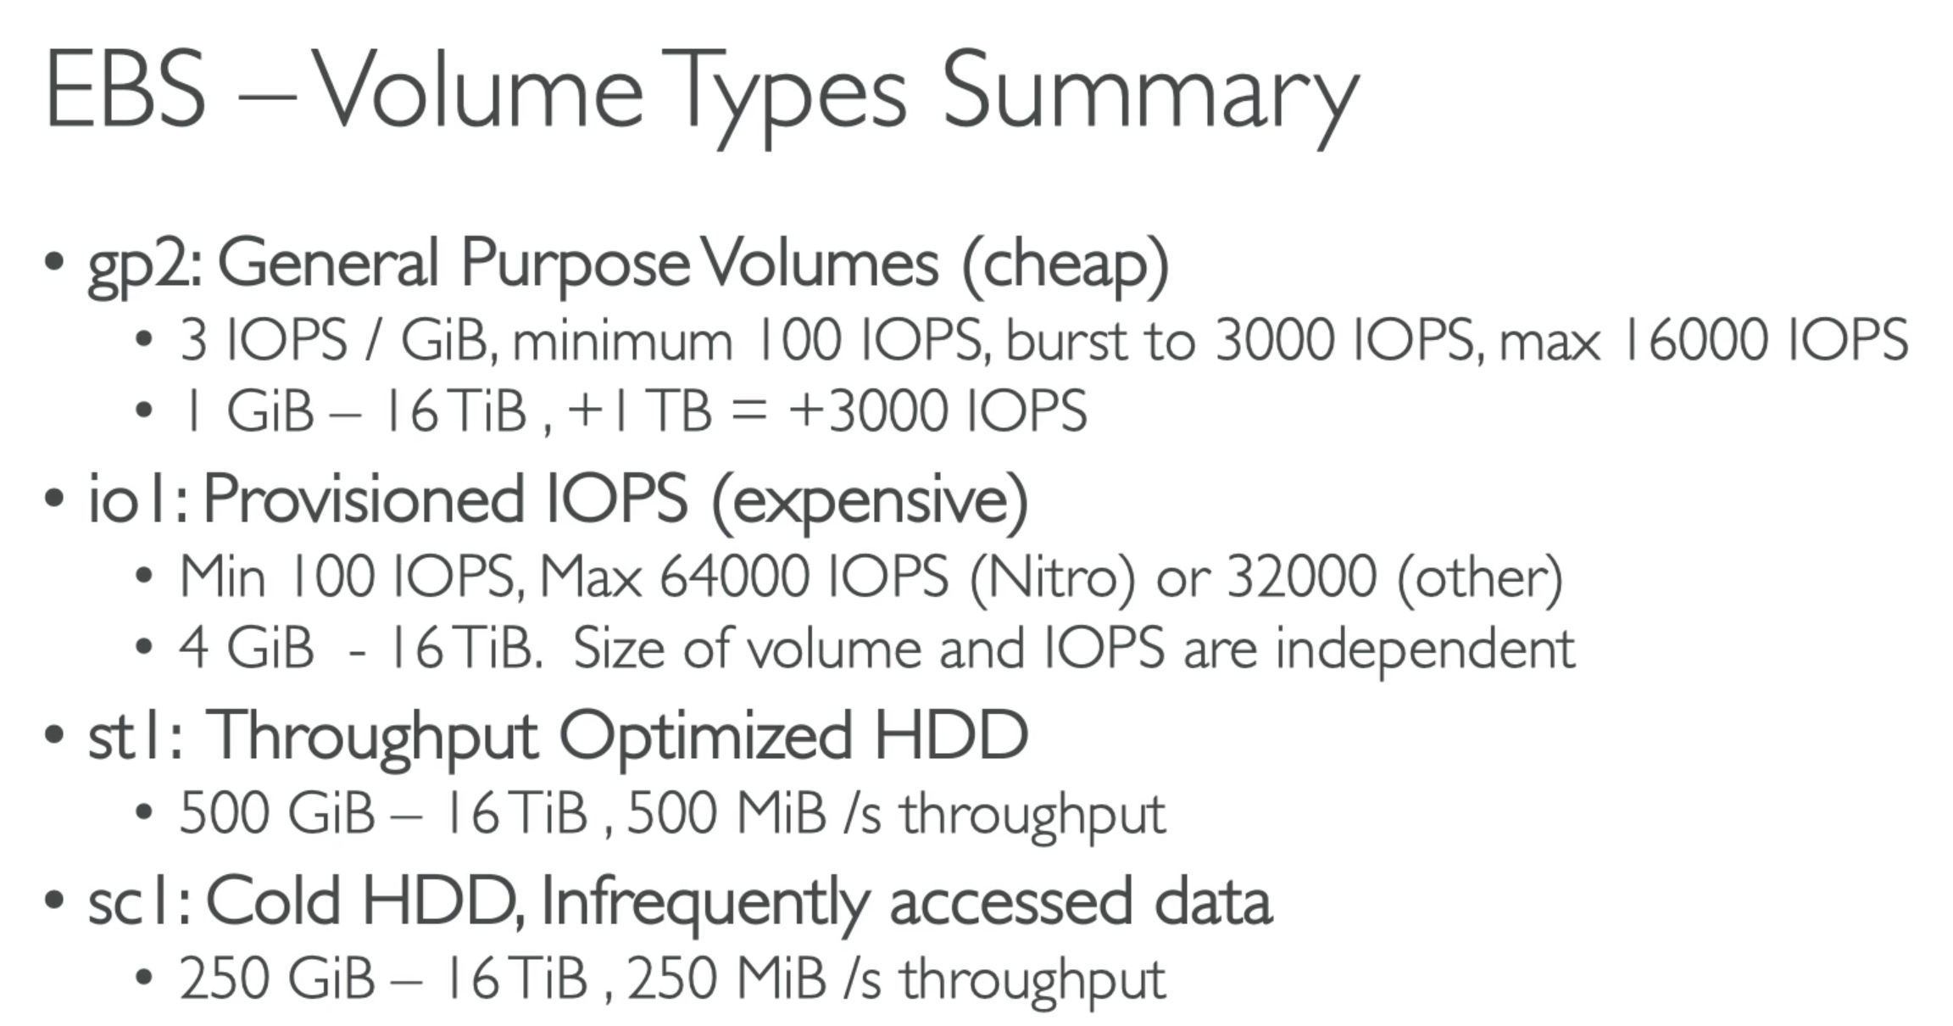

## 58. EBS Operation: Snapshots

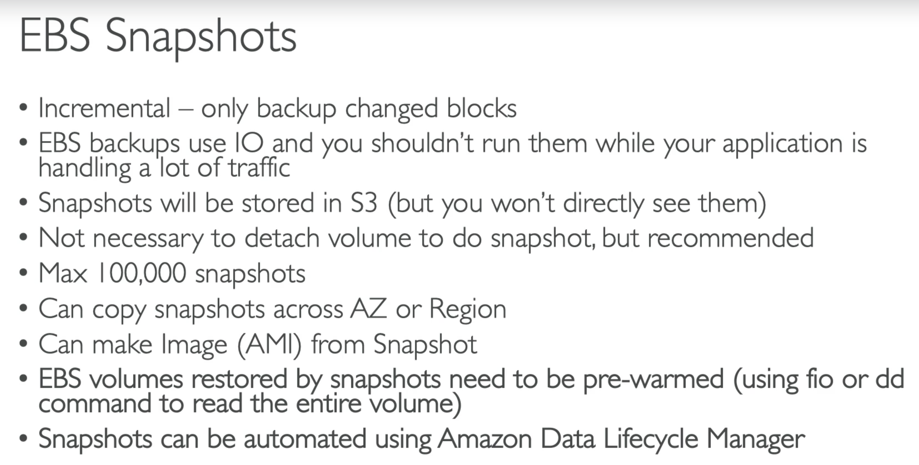

Steps to create Snap shots:

* Right click on the EBS volume 🡪 create snapshots

Snapshot Lifecycle Policy

You can create a policy, where based on tag snapshot will be scheduled…

## 59. EBS Operation: Volume Migration

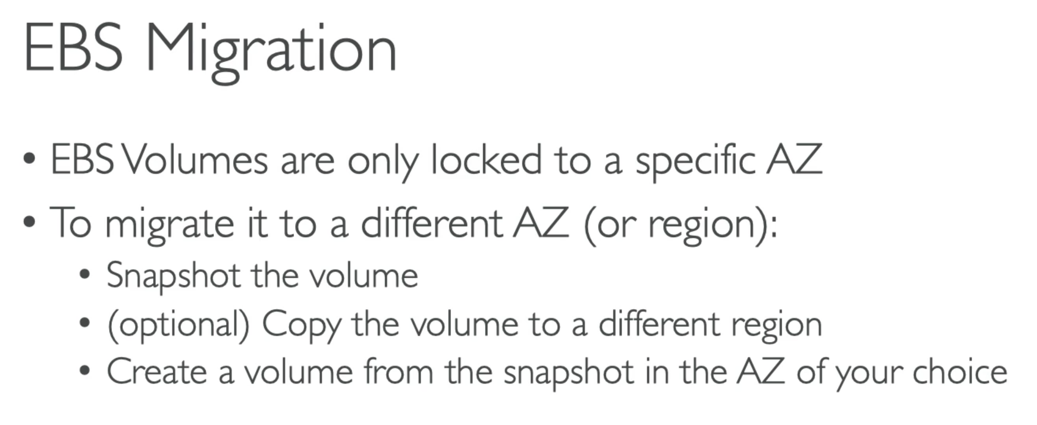

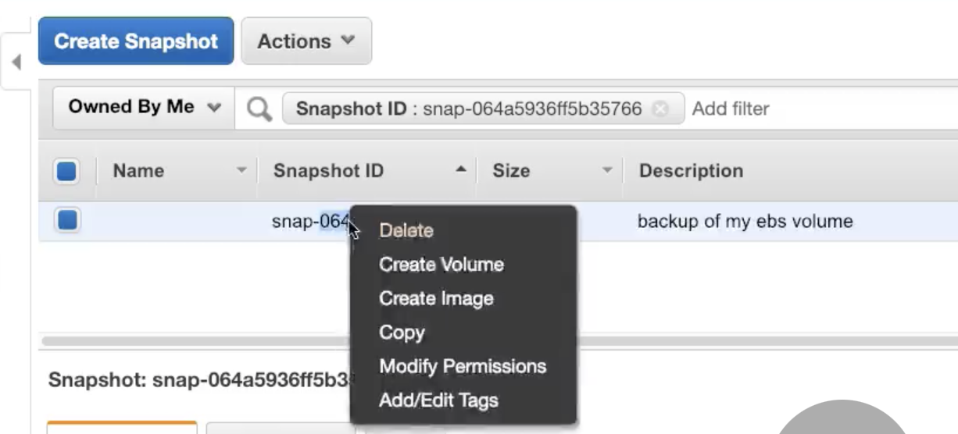

## 60. EBS Operation: Volume Encryption

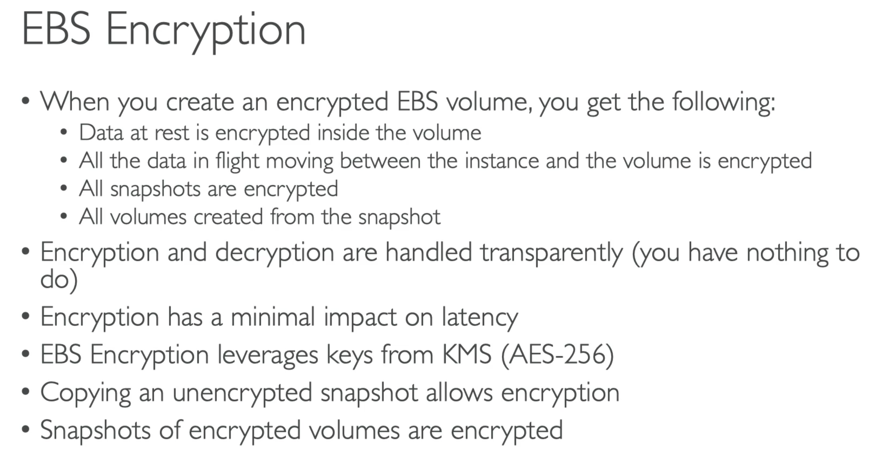

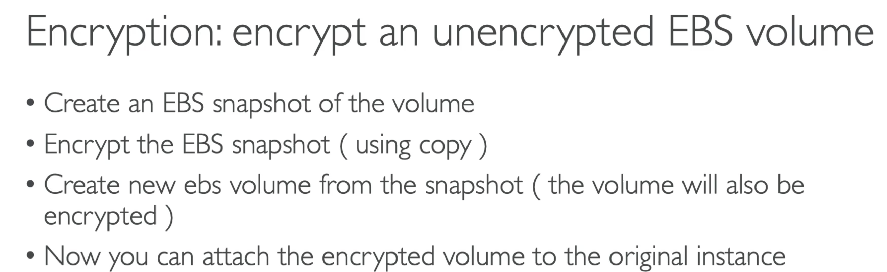

## 61. EBS vs Instance Store

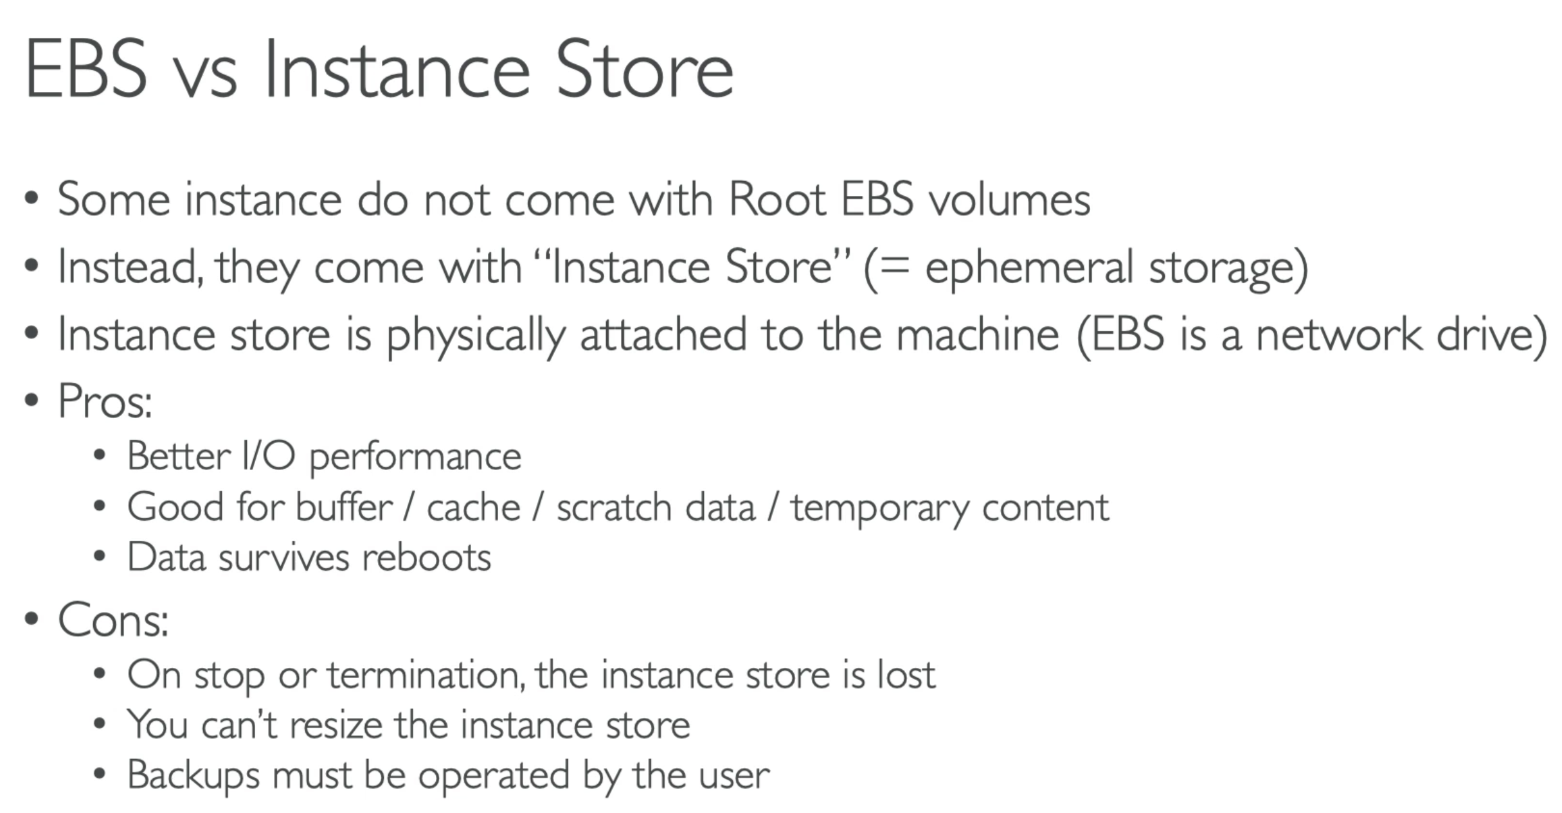

### ExamTip:

If in the exam they ask you to choose instance store vs EBS volume…

* Think if you are ok to lose your data or if your data is ephemeral … if yes, you can go for instance store

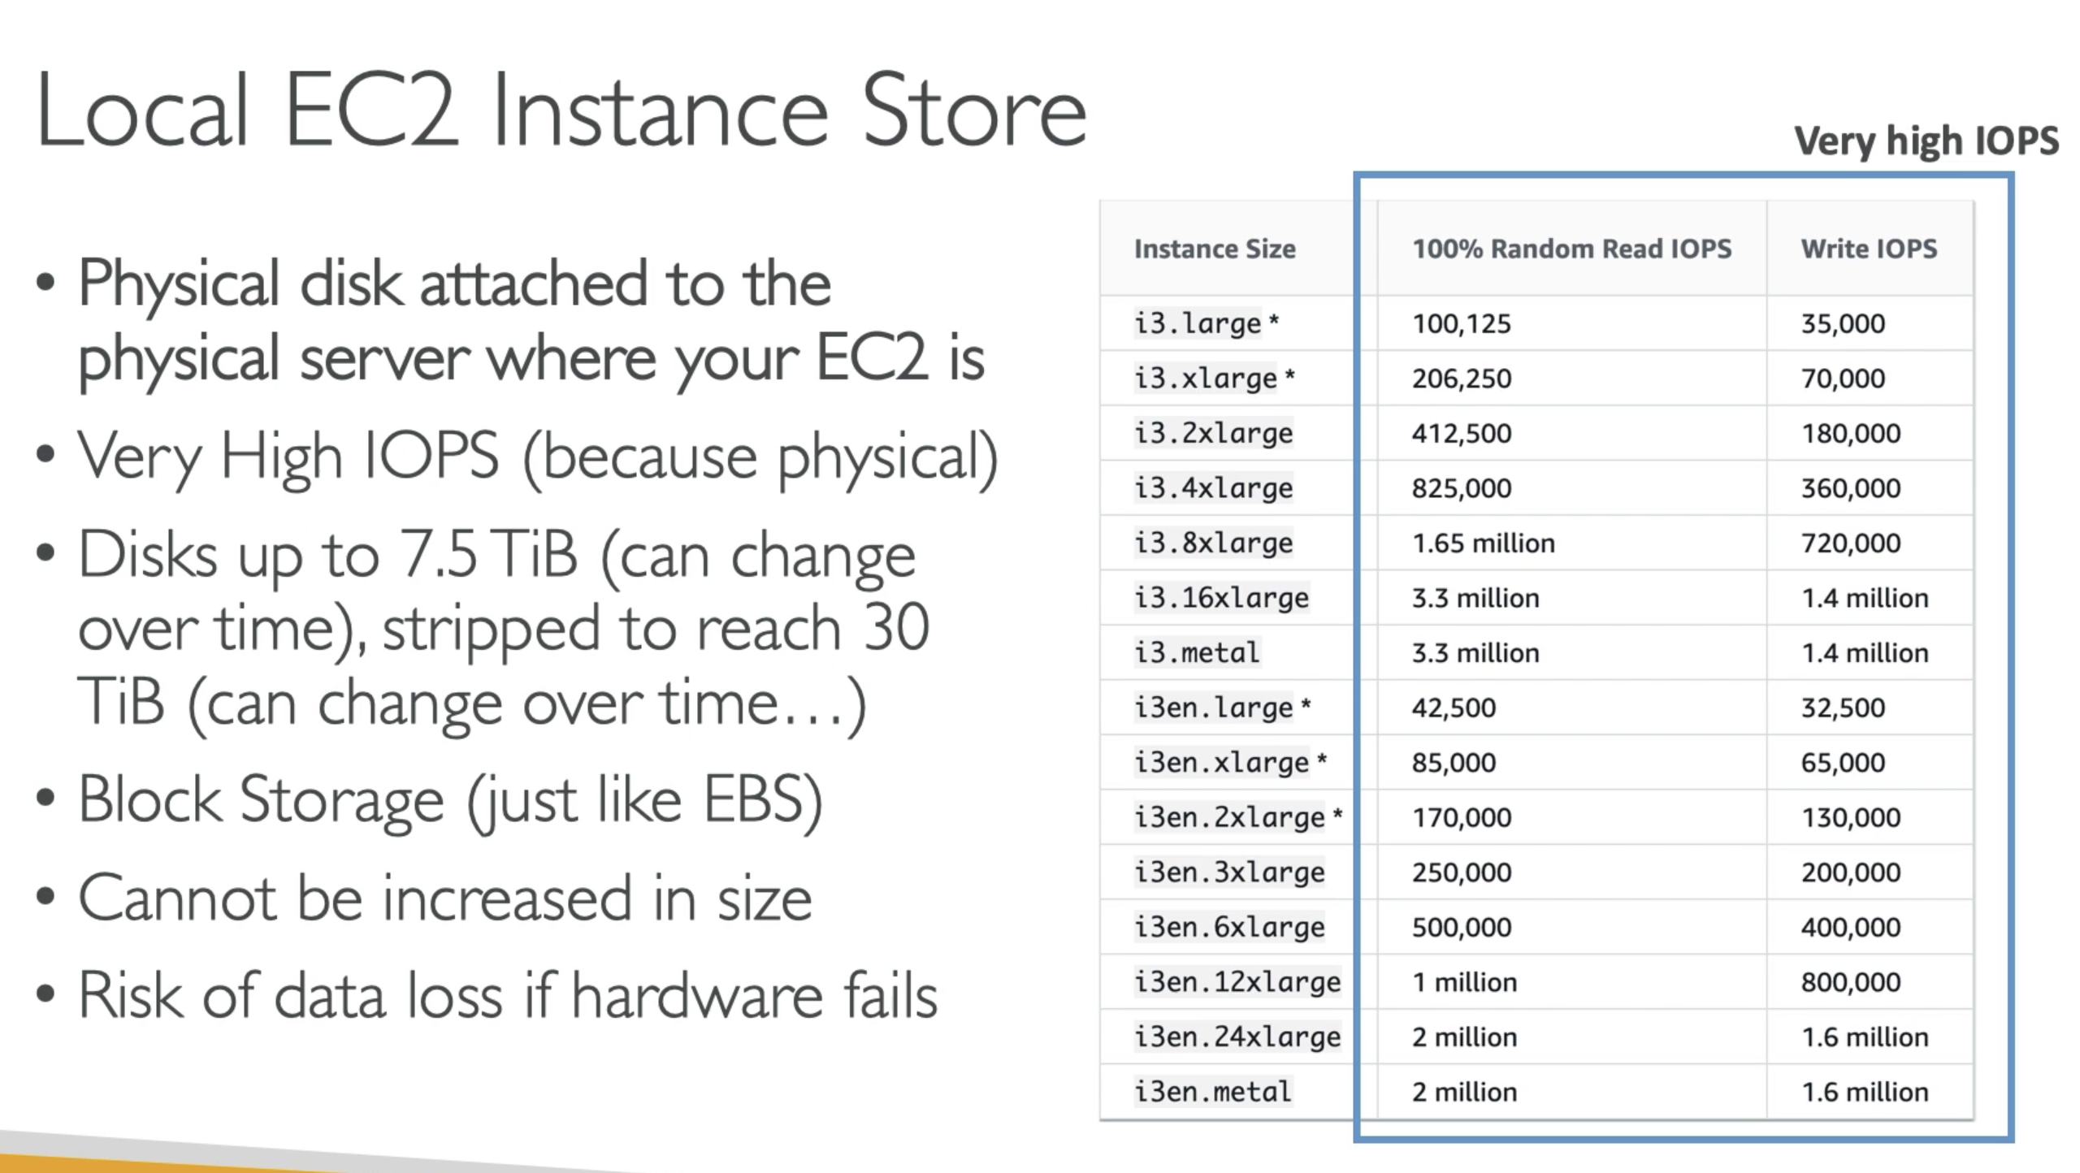

## 62. EBS RAID Configurations

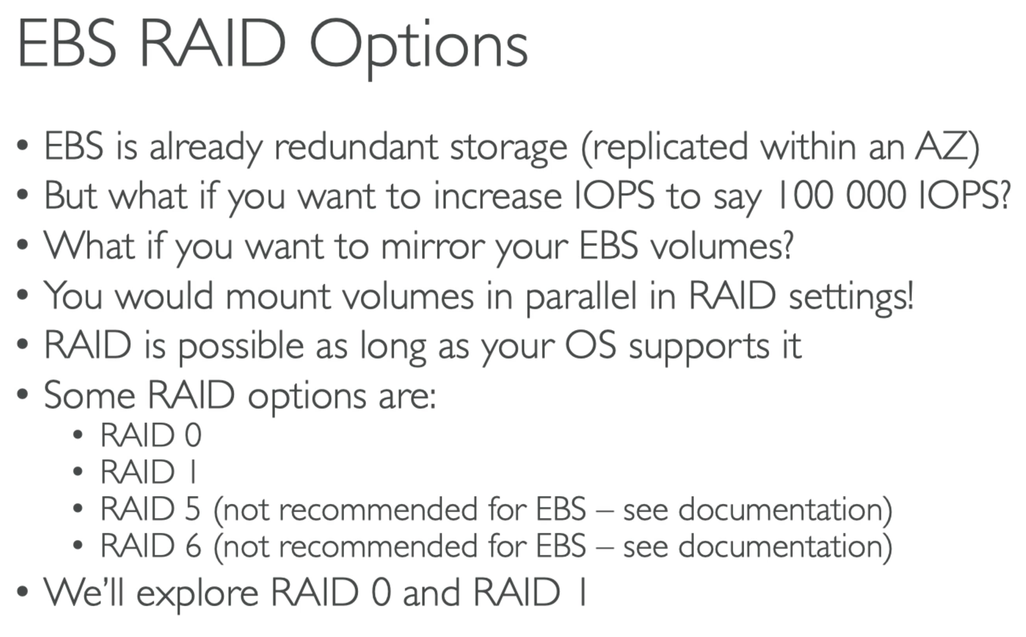

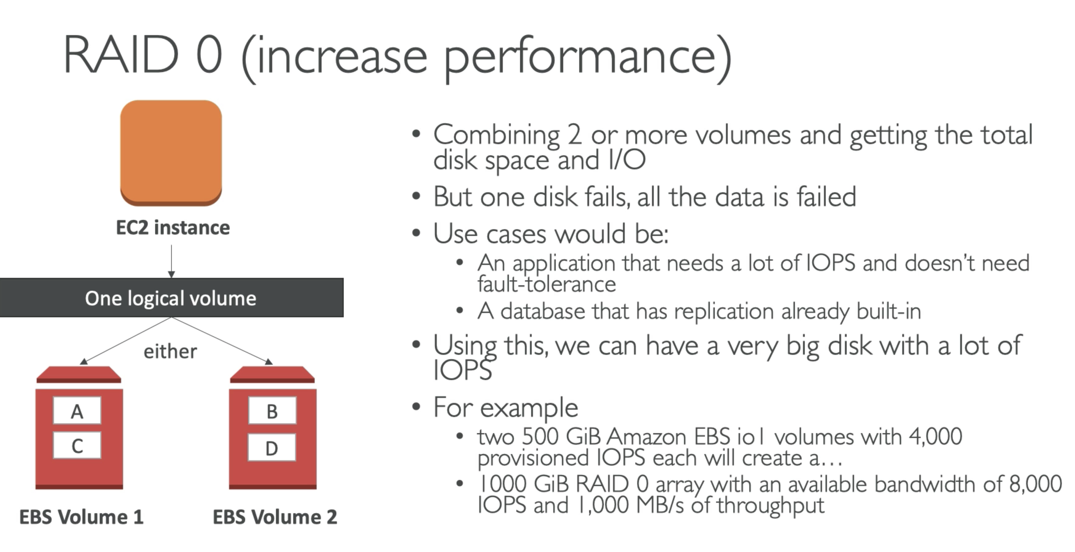

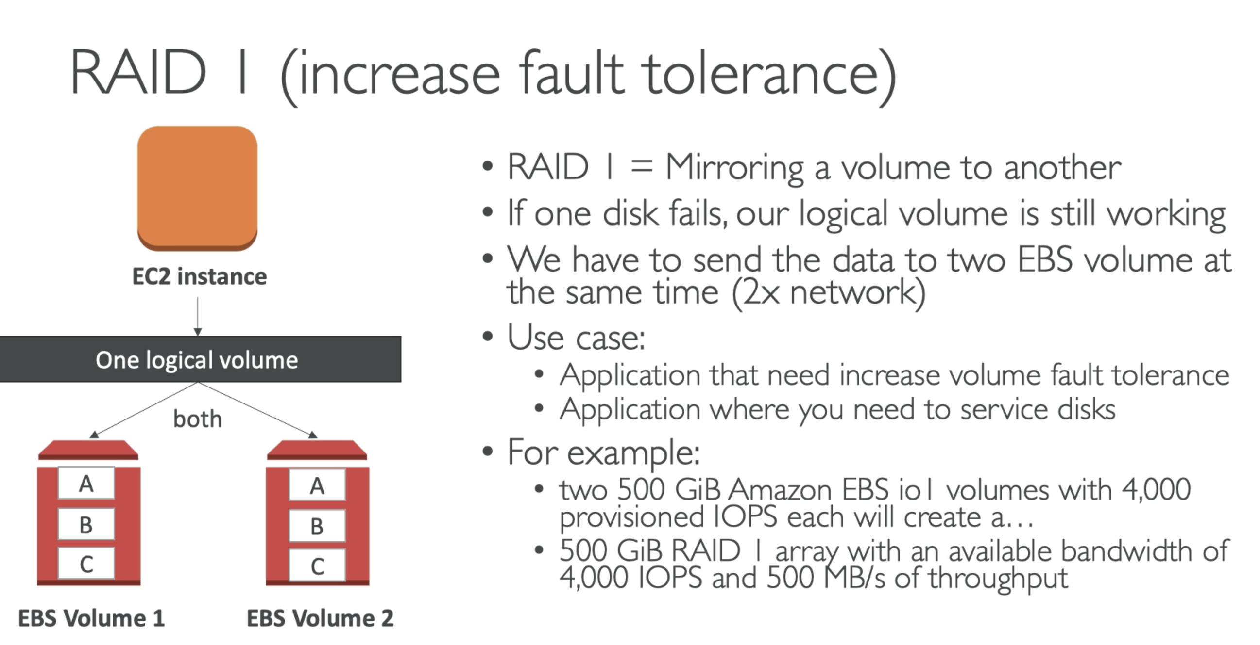

## 63. EFS Overview

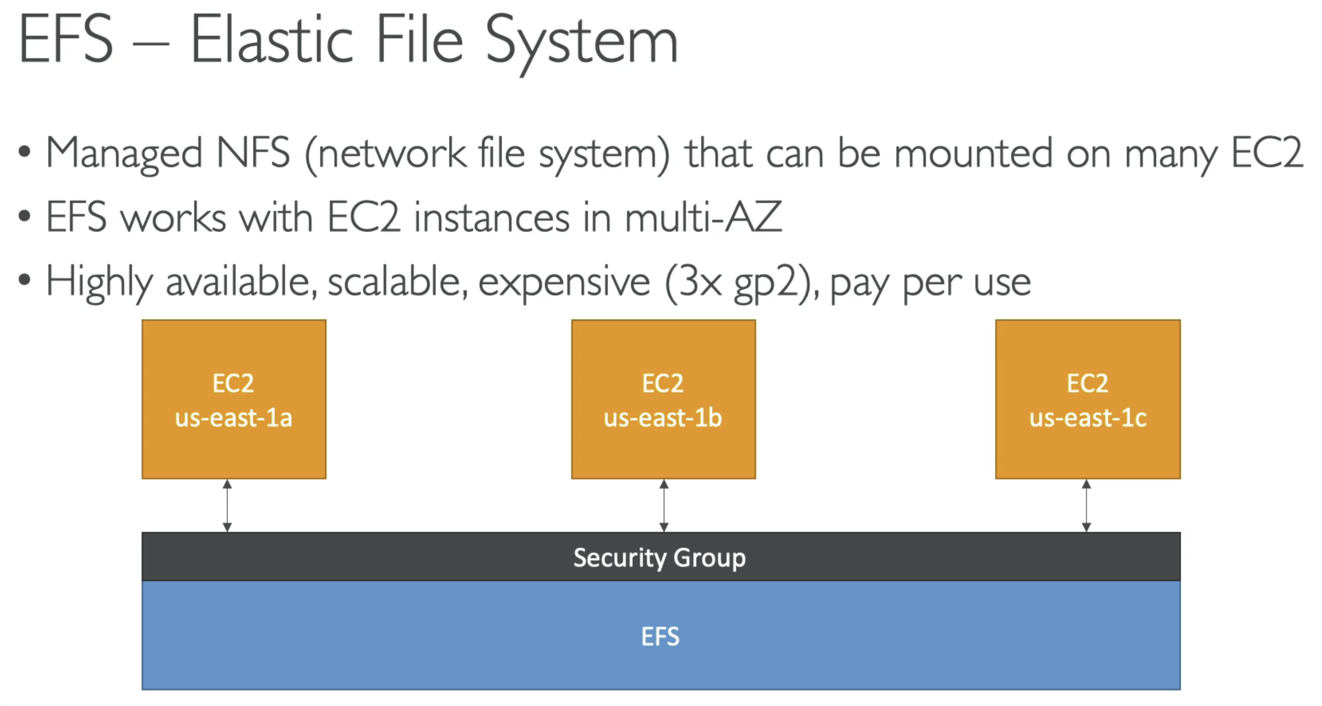

* EBS was mountable on a single AZ, where as EFS can be mounted on multi-AZ…

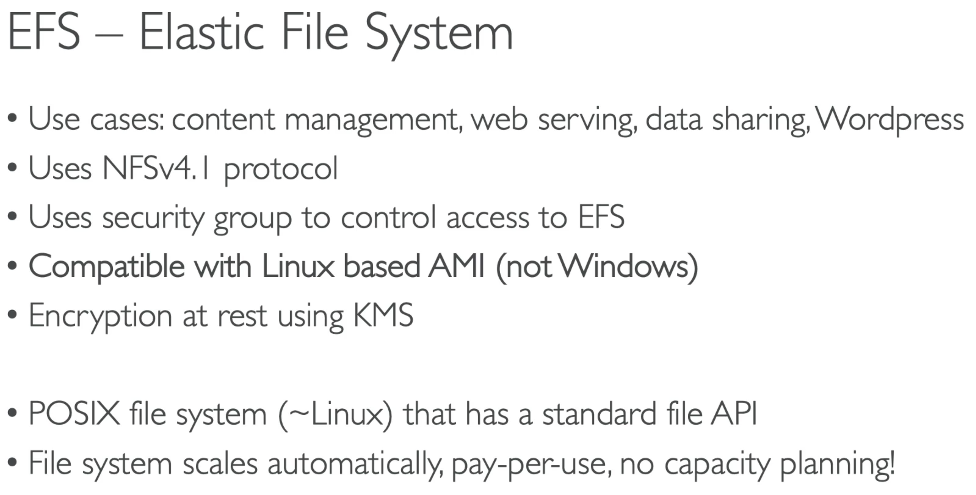

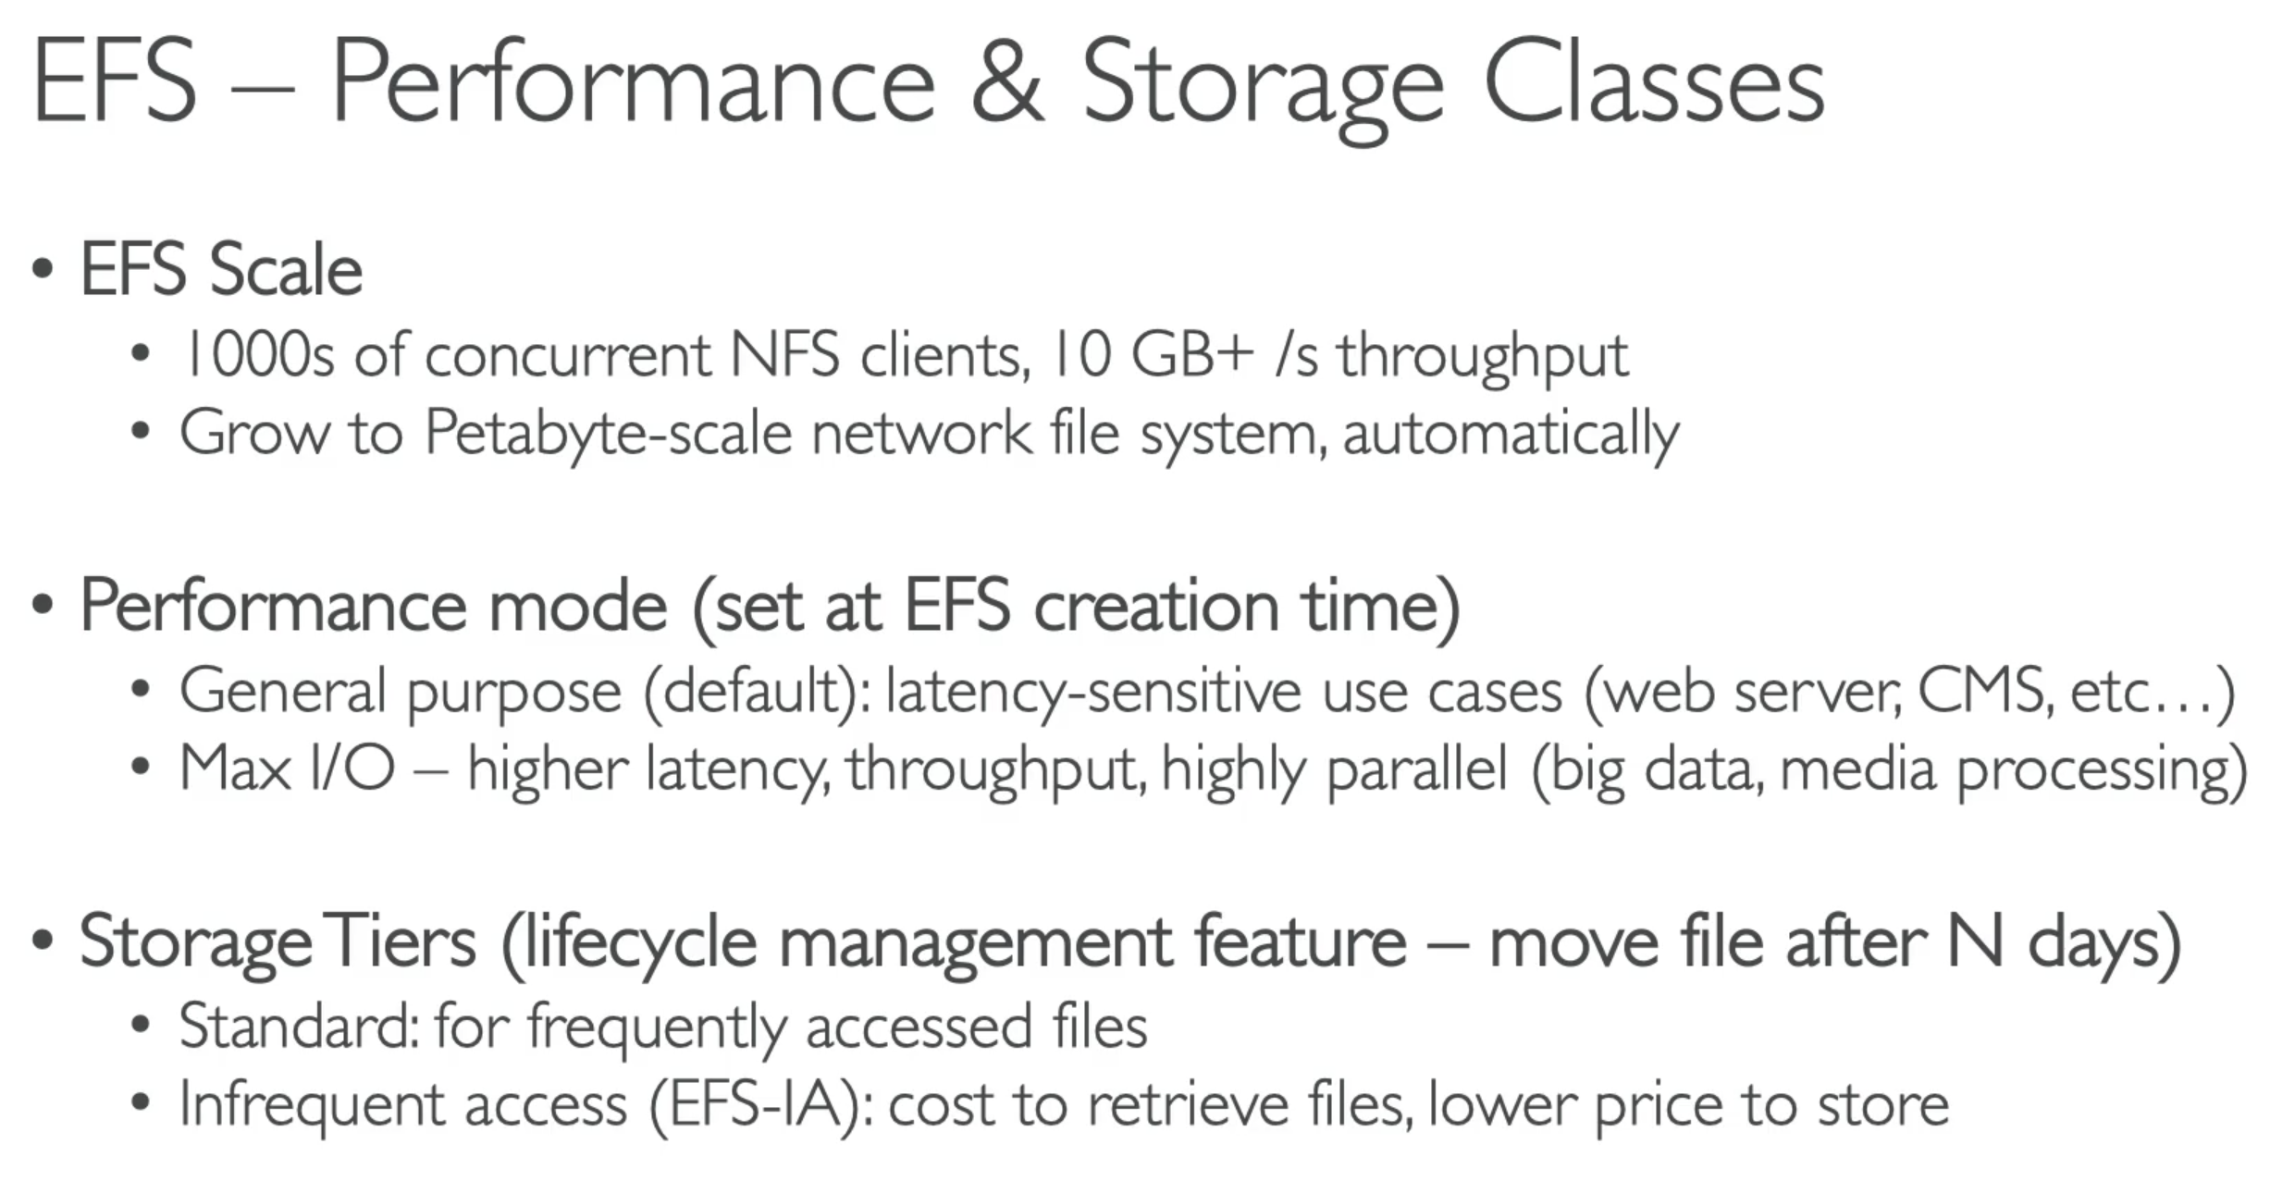

**EFS-IA can come up in the exam

## 64. EFS Hands On

## 65. EBS & EFS – Section Clean up

## 66. EFS vs EFS

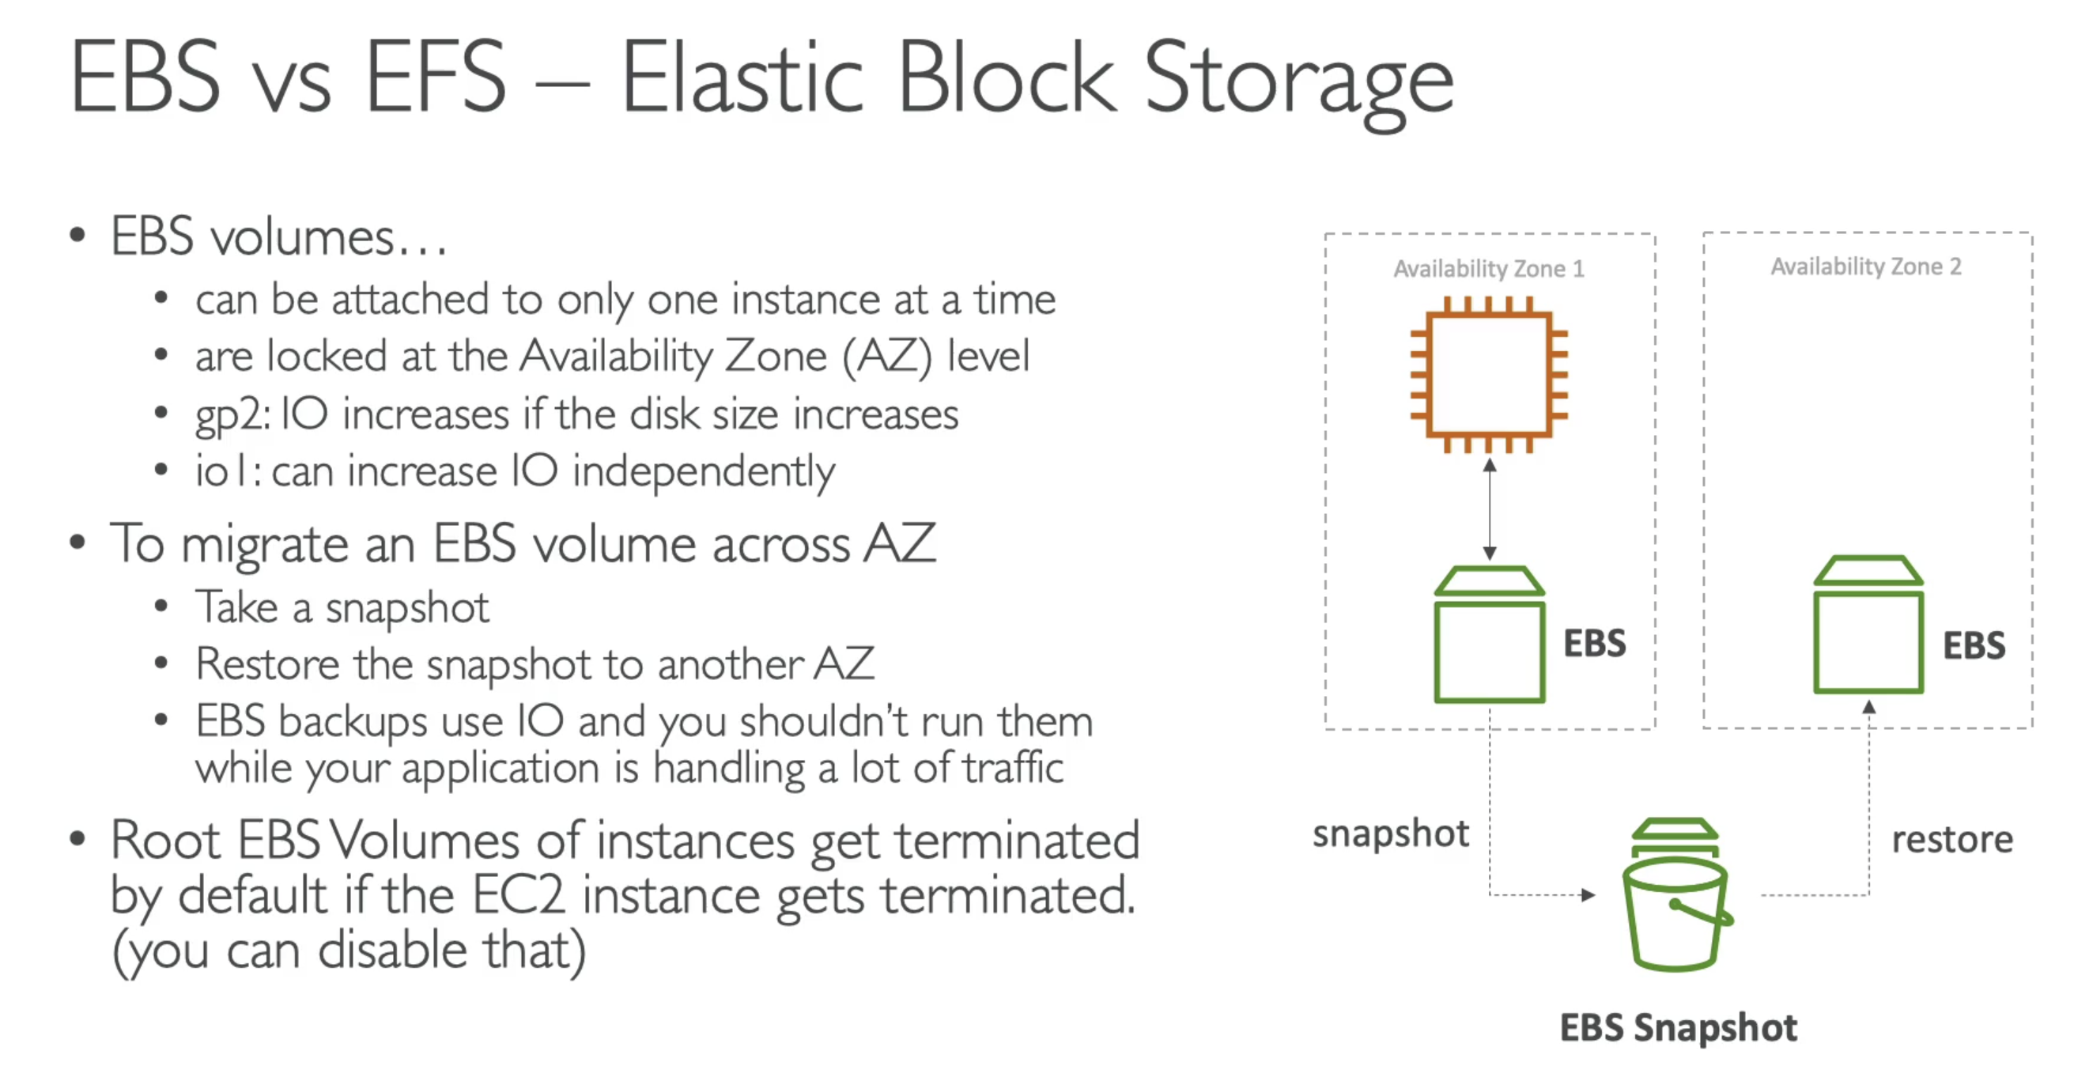

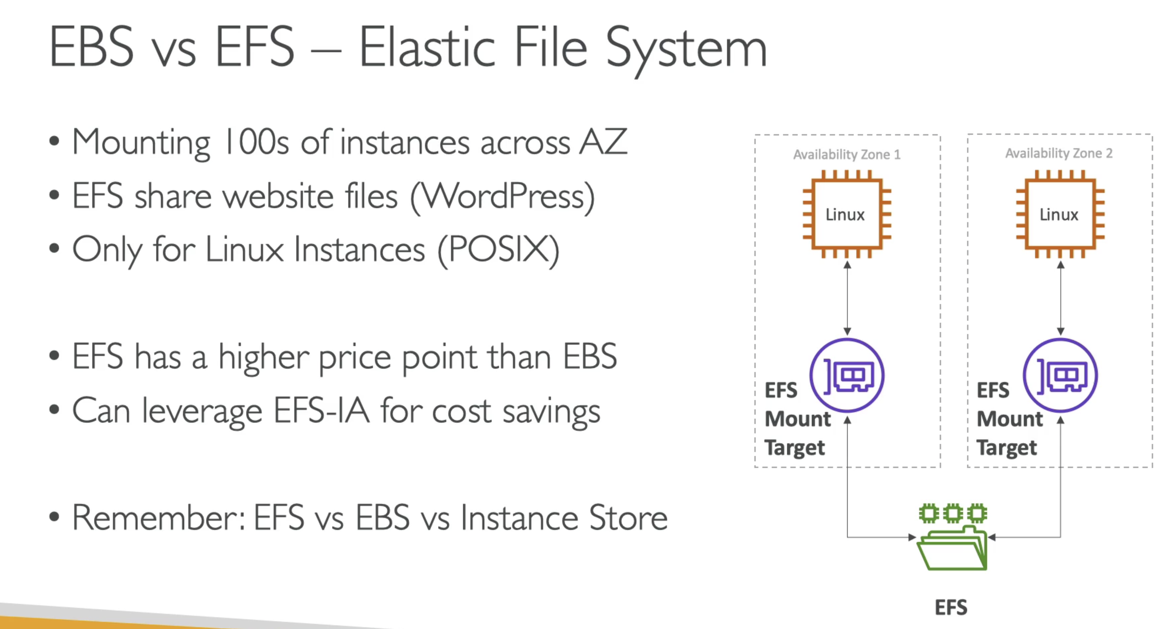

Imp:

* EFS is for network file system to be mounted across multiple instances
* EBS is network volume that is mounted to only one instance, and is locked to an AZ
* Instance Store is to get max amount of IO to an ec2 instance but you lose data if you lose the instance.

# Section 16: AWS Storage Extras

## 166. Snowball Overview

### Snowball Overview

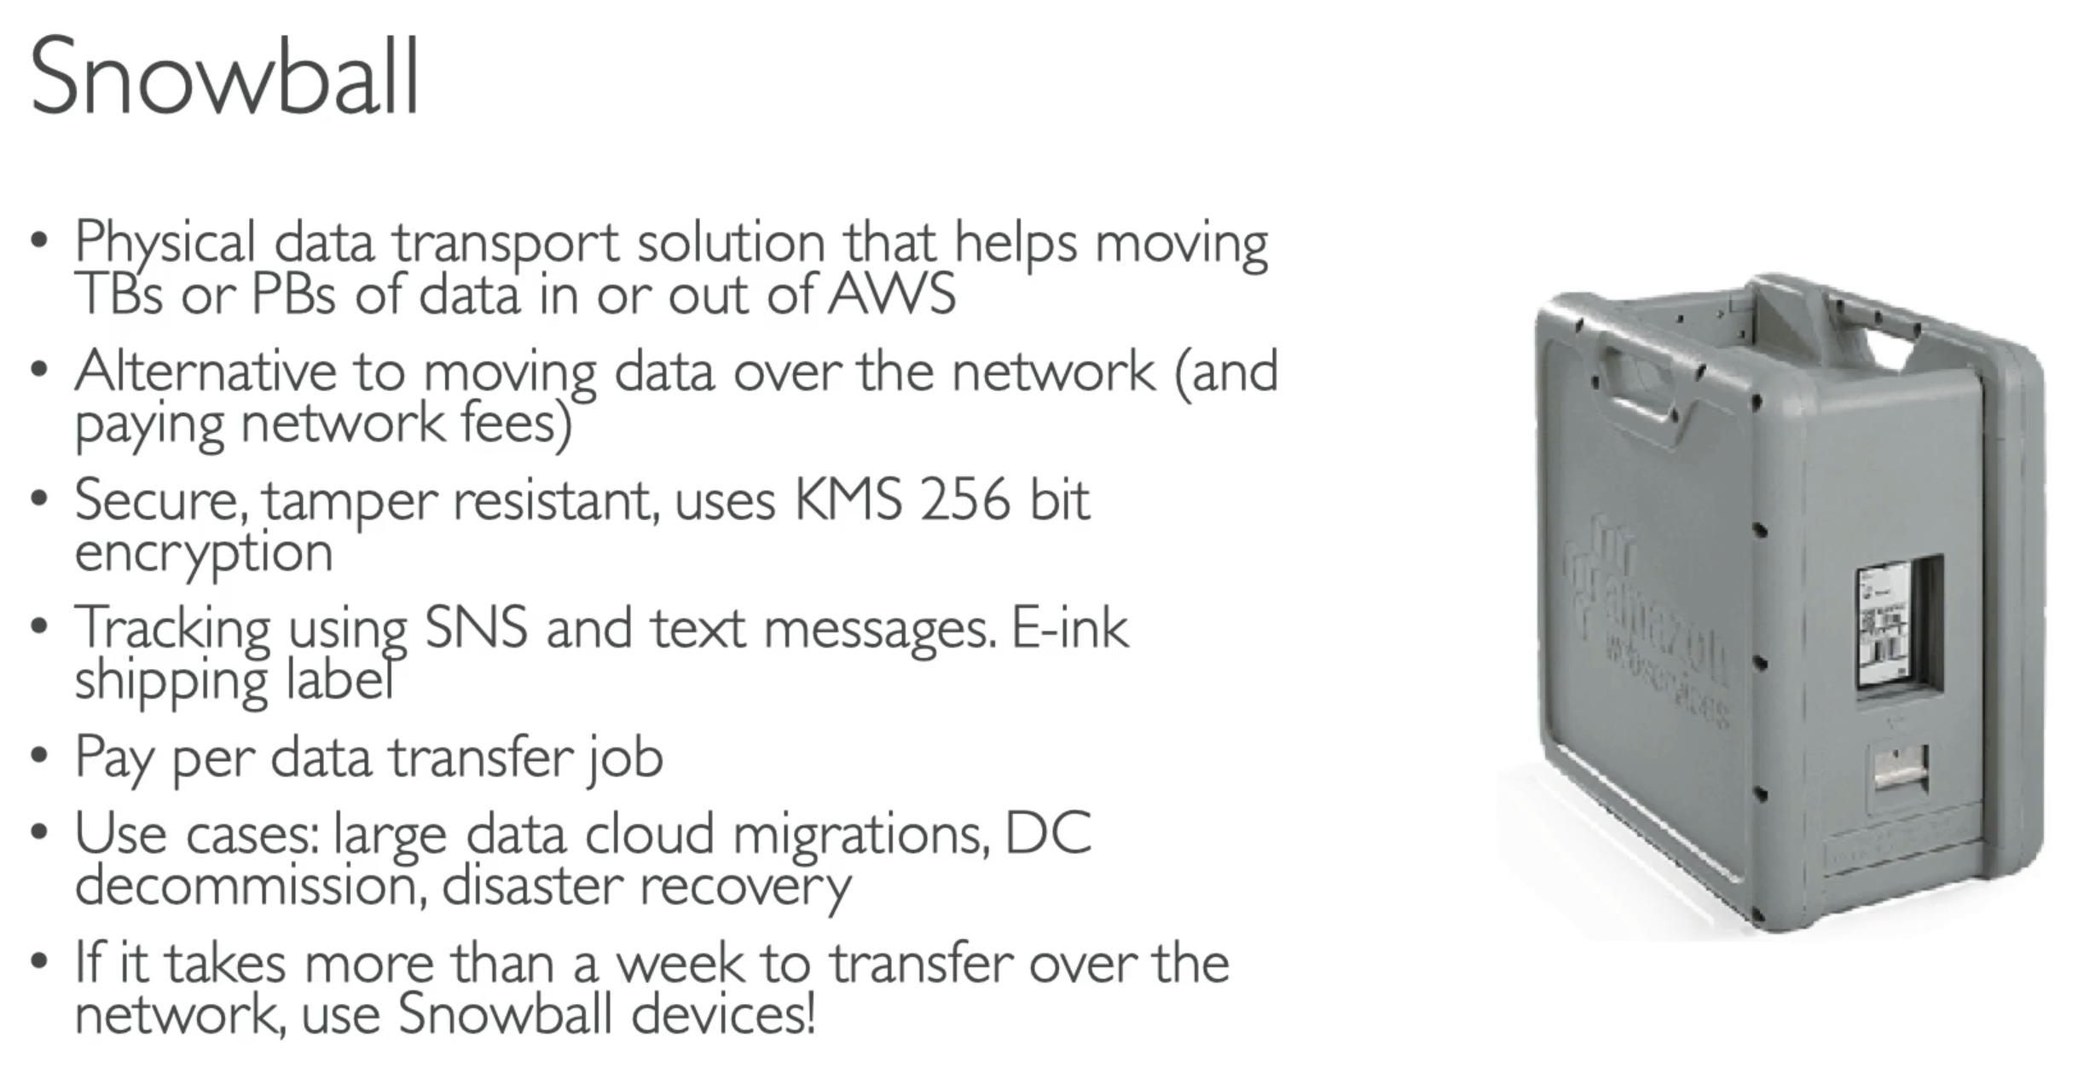

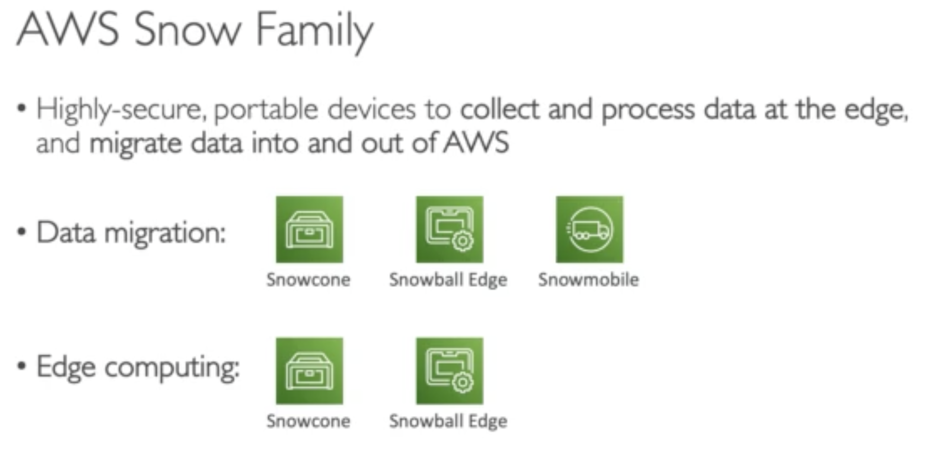

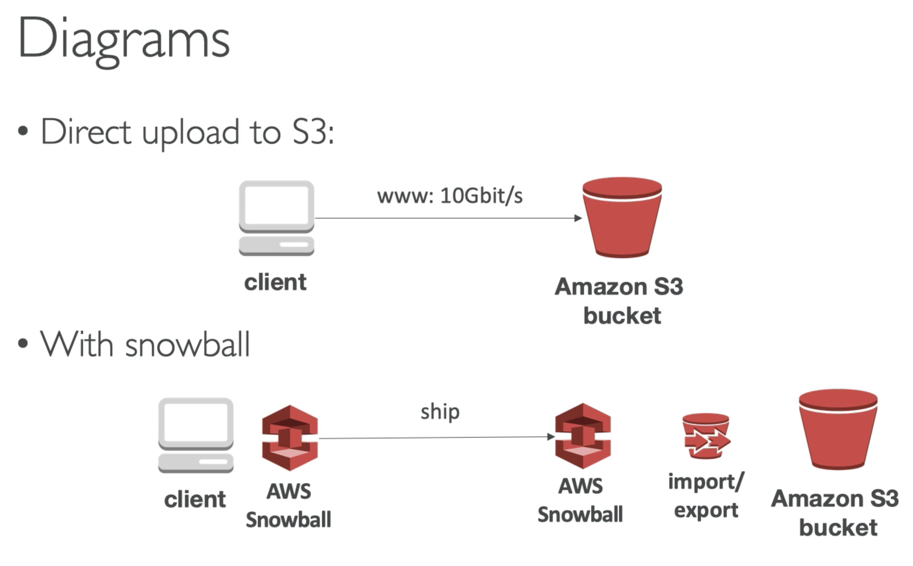

### Snow-cone

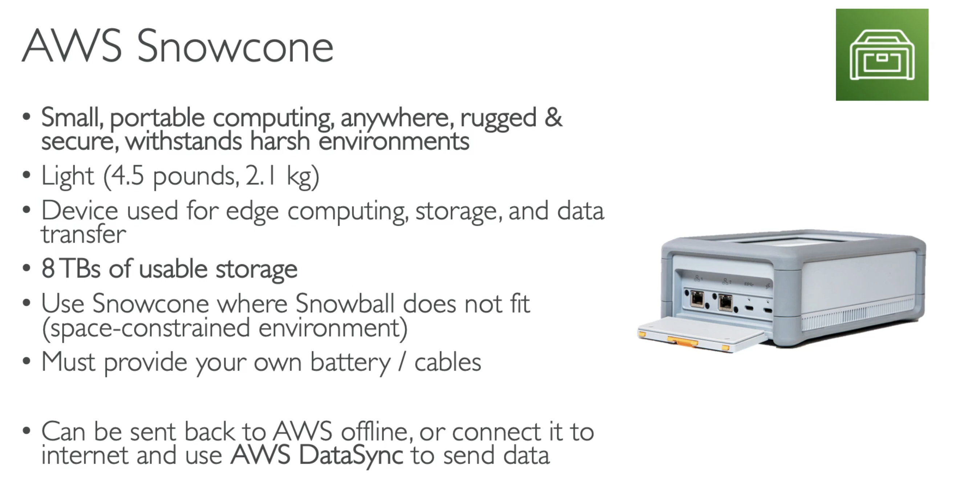

### Snow-mobile

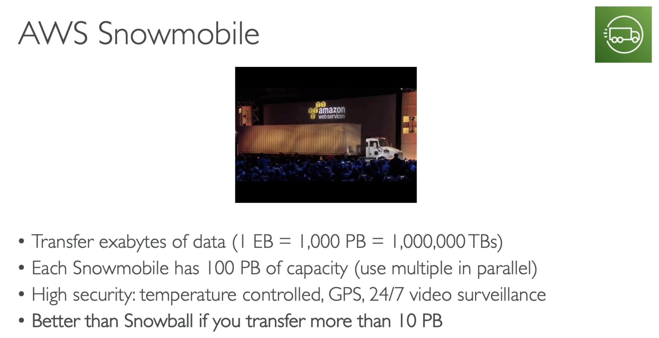

### Snow Family - Compare

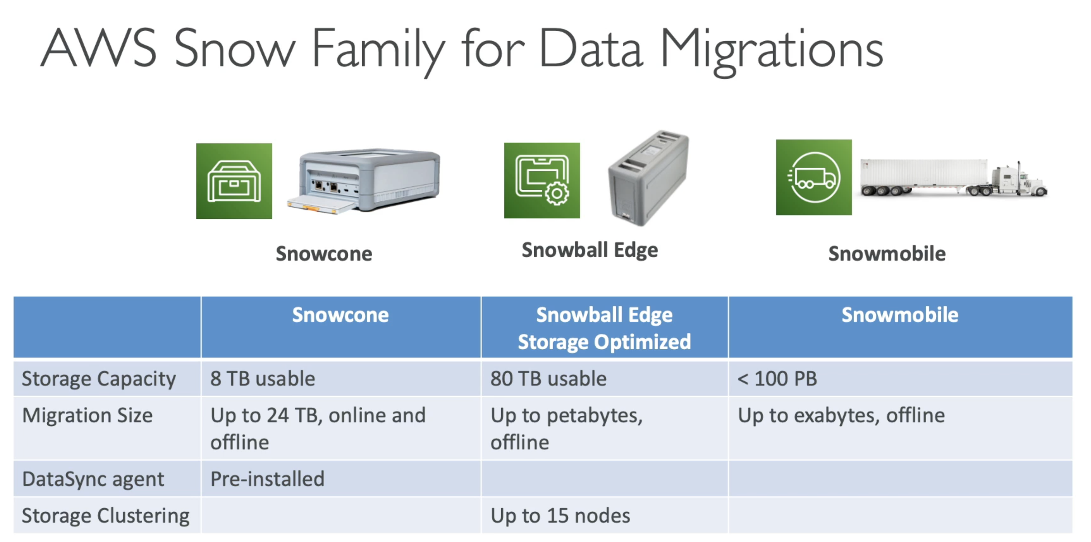

### Usage Process

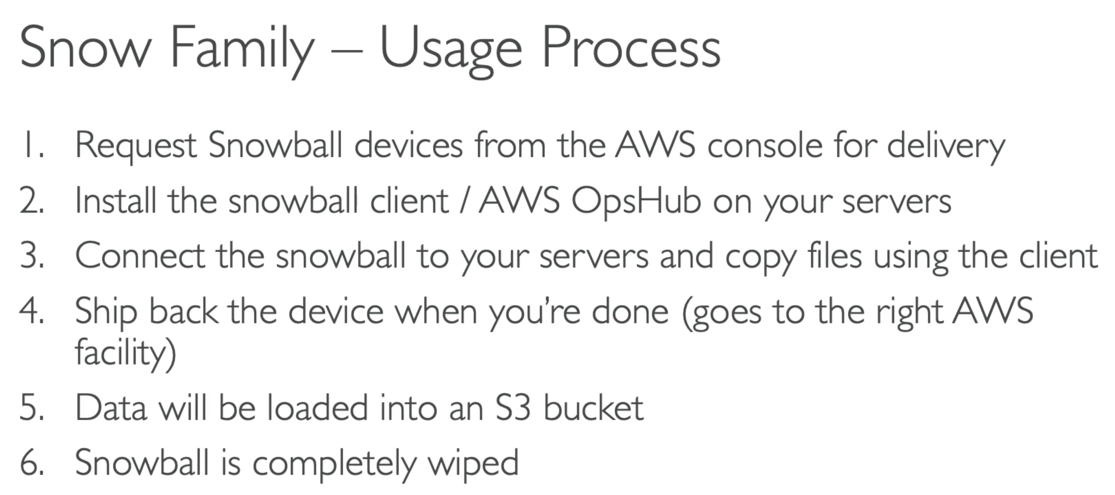

### Edge Computing

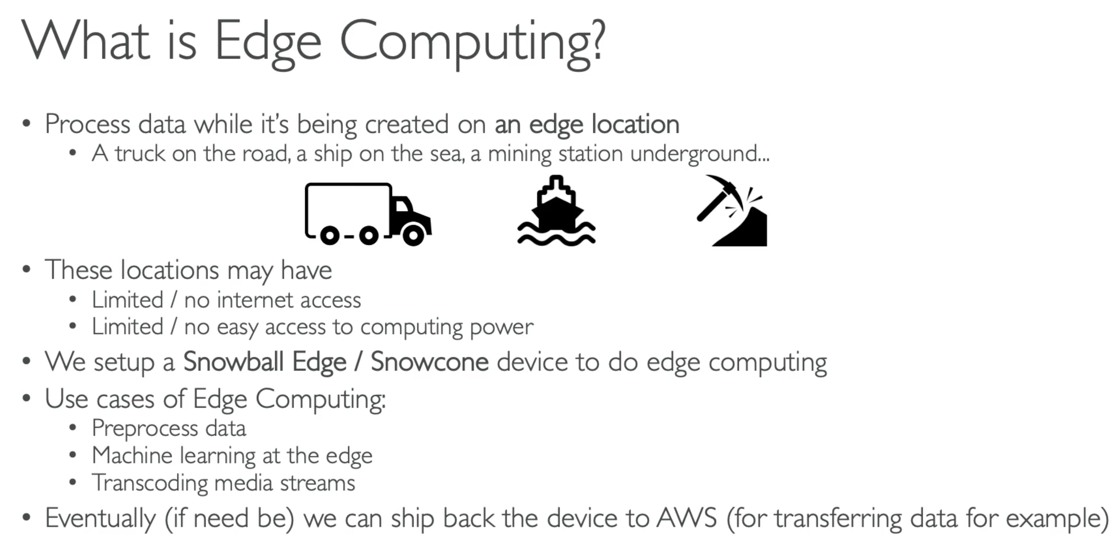

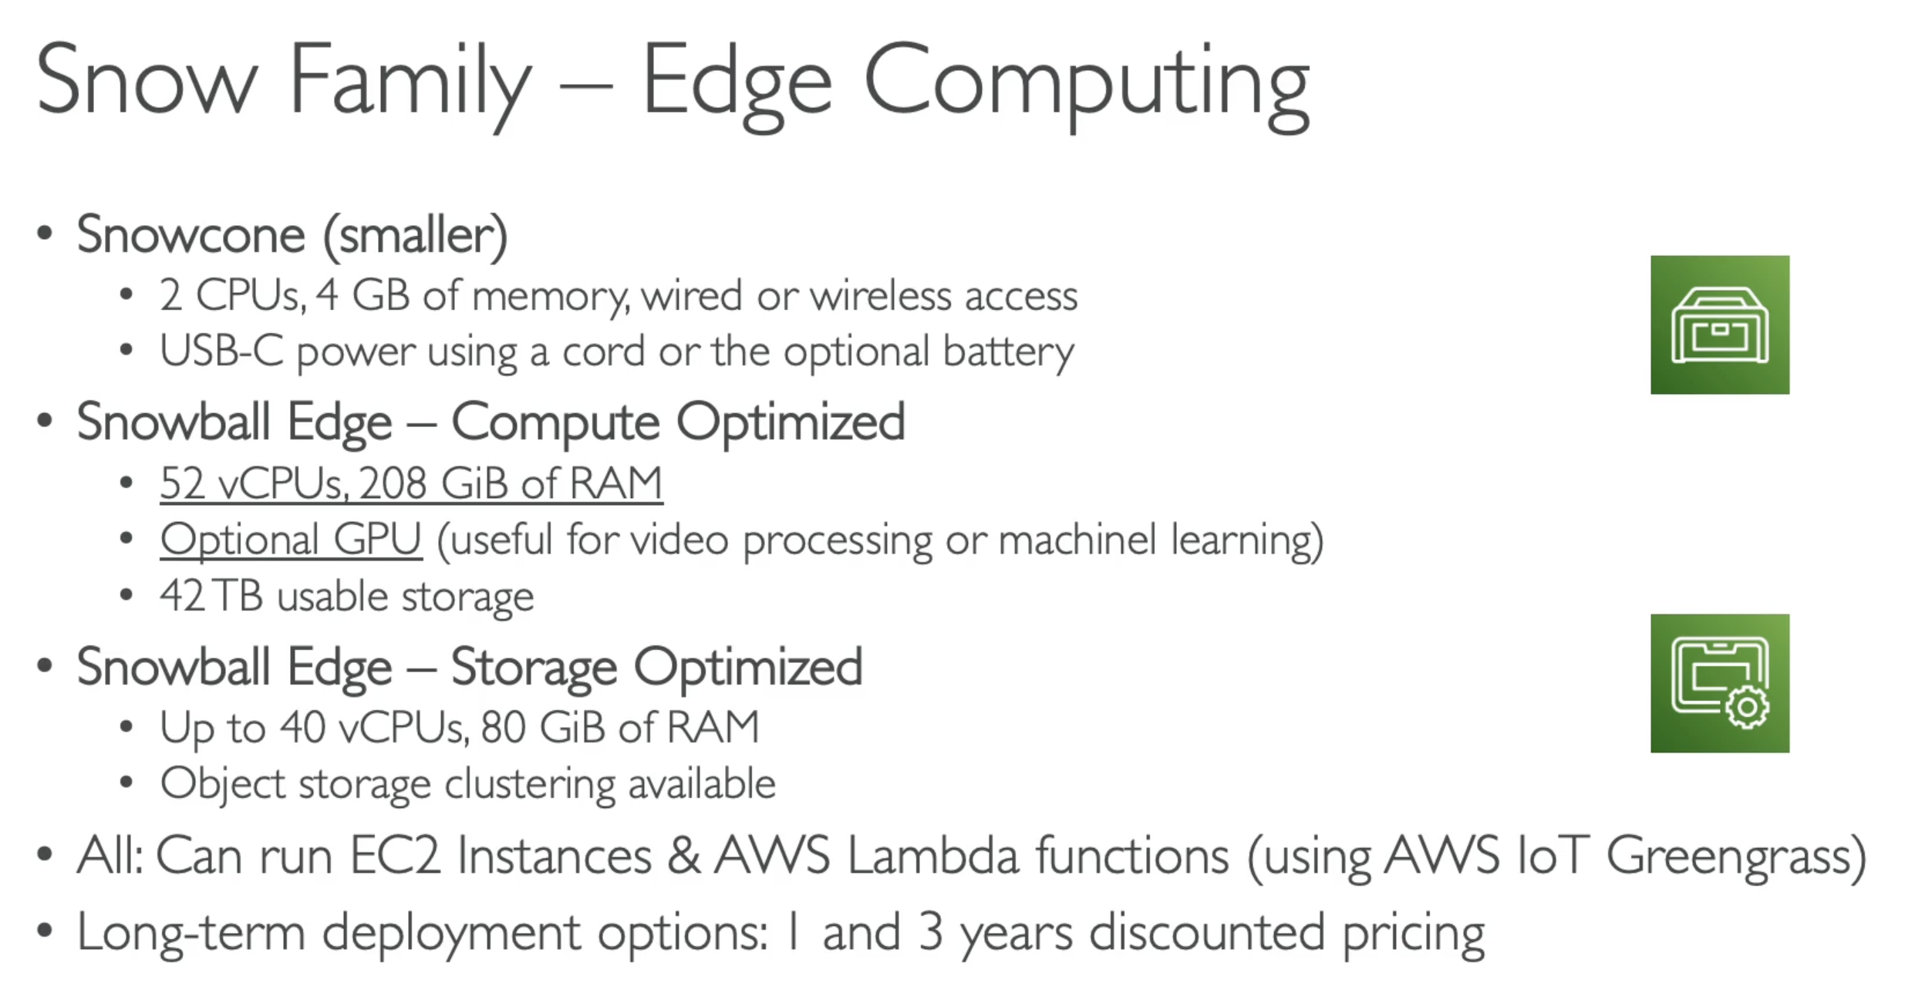

### OpsHub

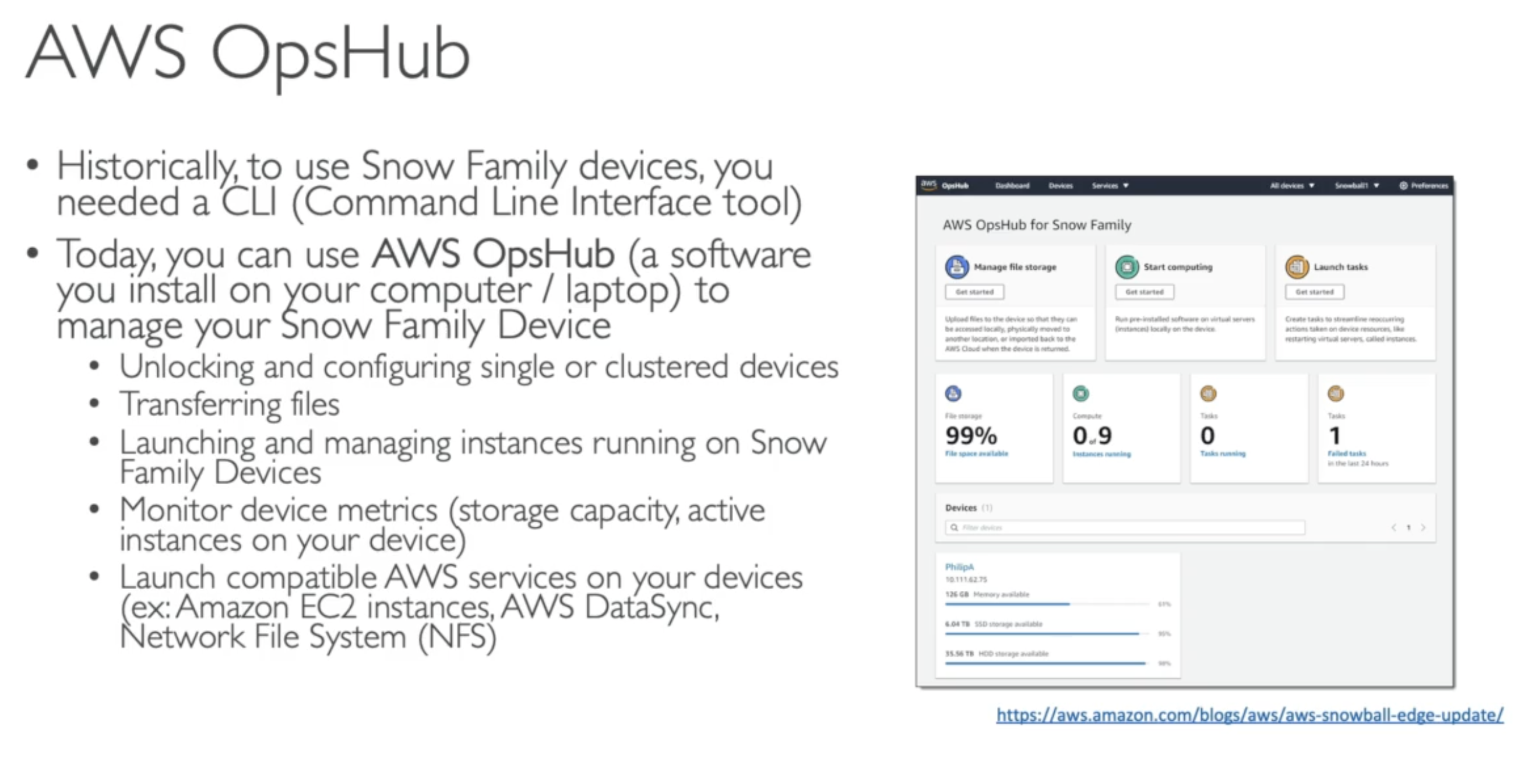

## 168. Architecture: Snowball into Glacier

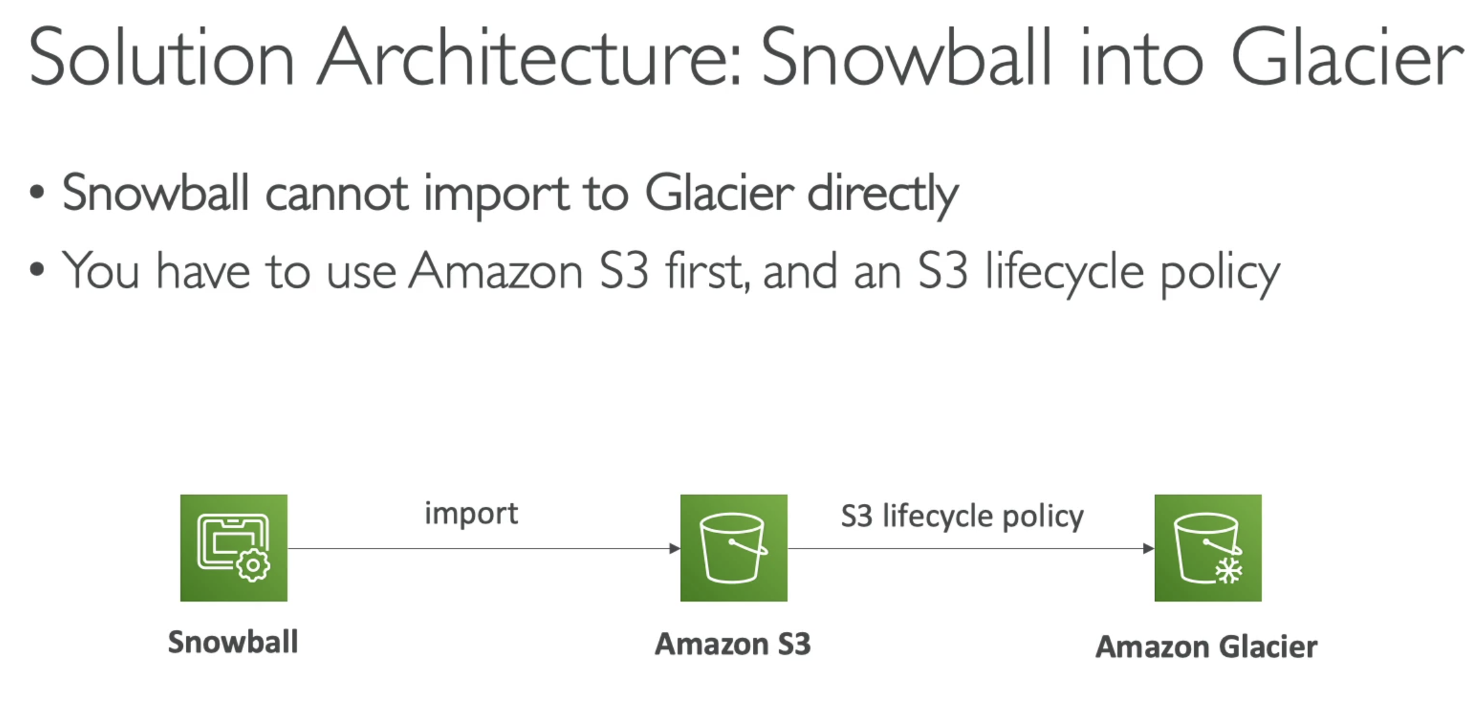

## 168. Storage Gateway Overview

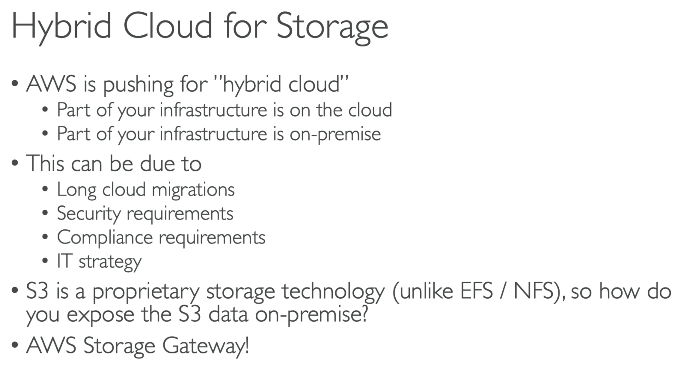

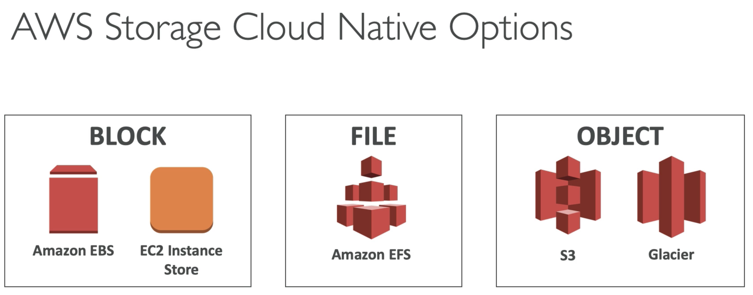

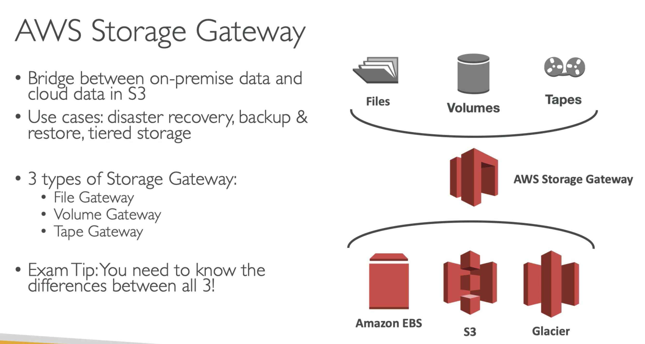

### ExamTip – Know the difference between File – Volume - Tapes Gateway

### File Gateway

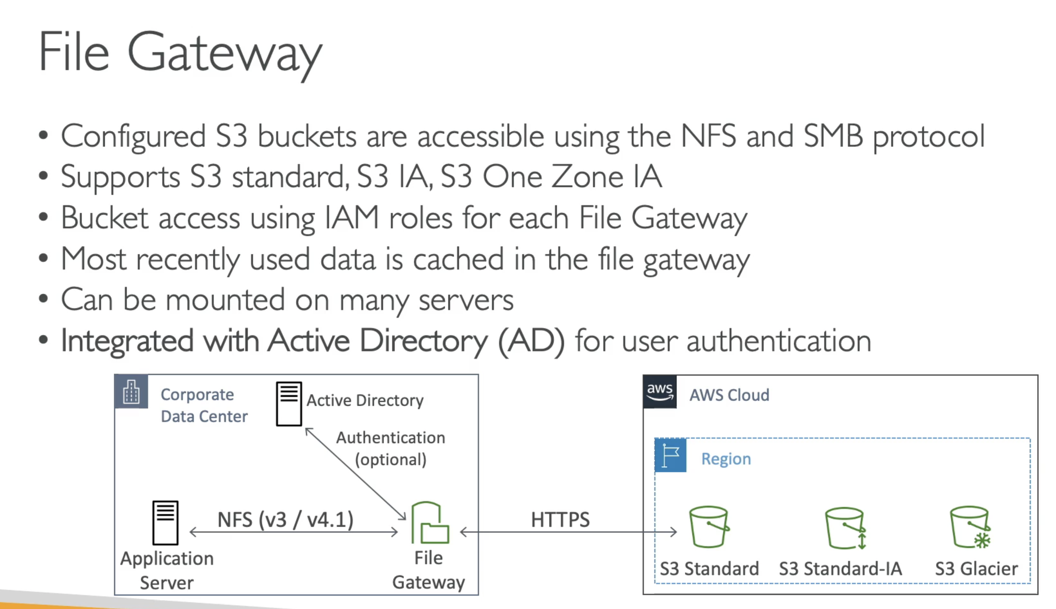

### Volume Gateway

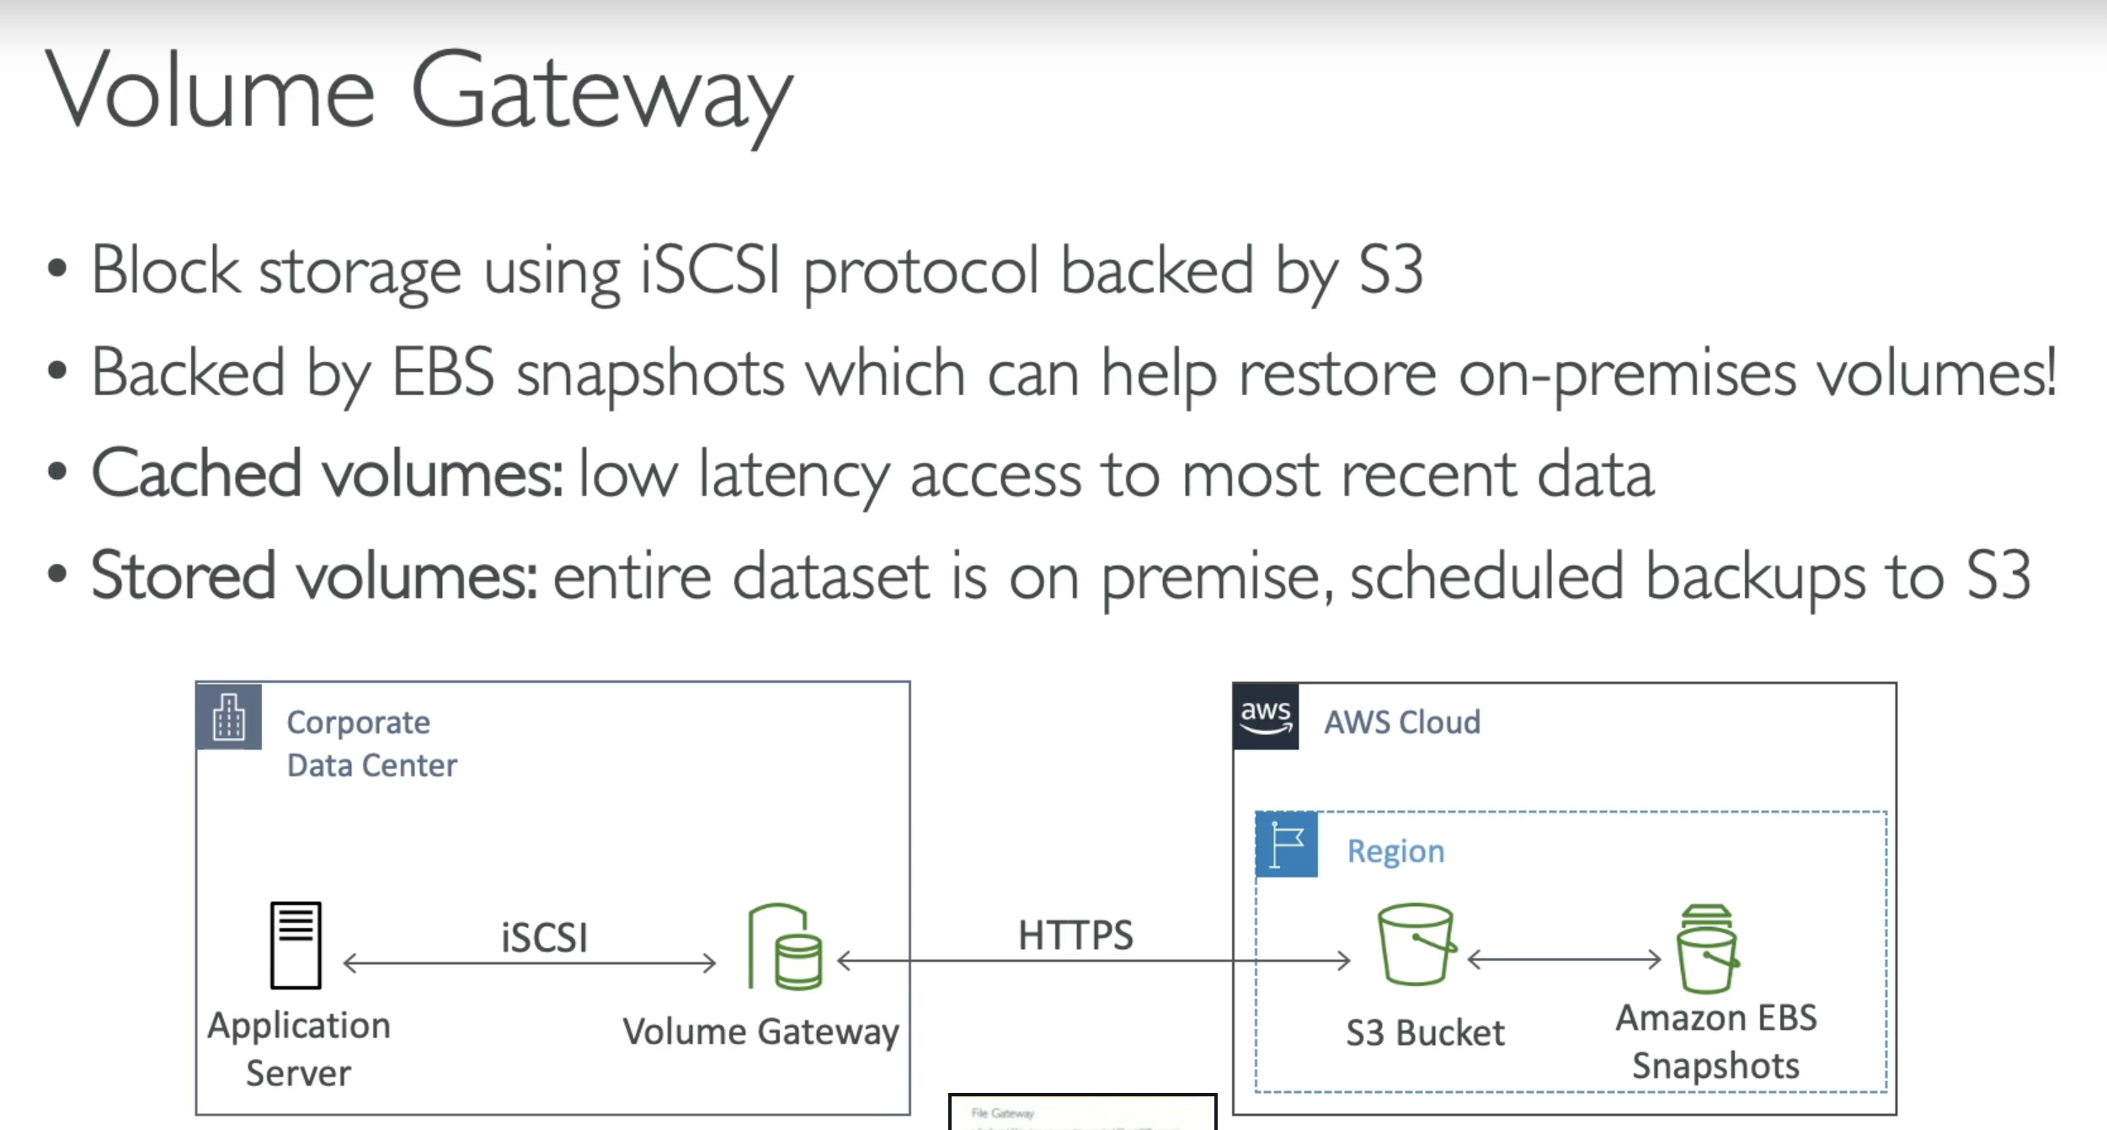

### Tape Gateway

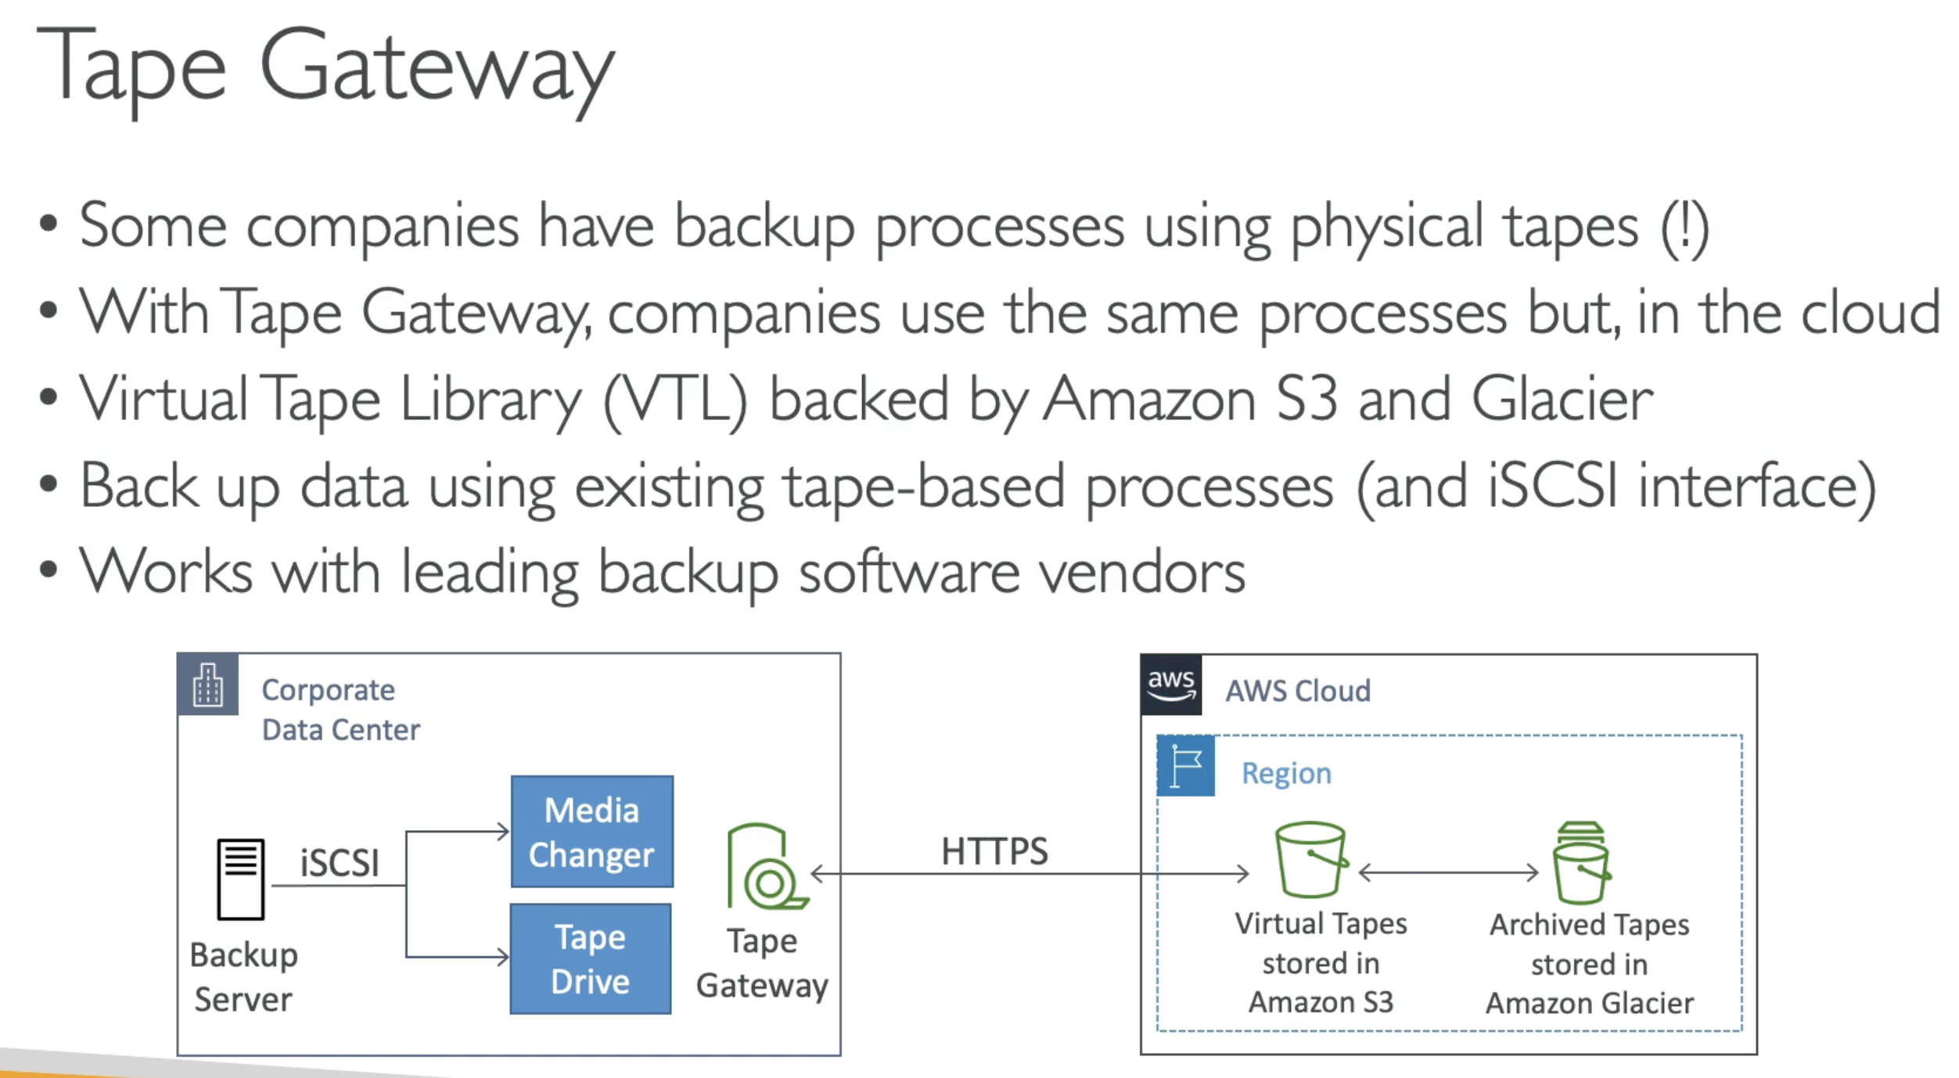

### Hardware Appliance

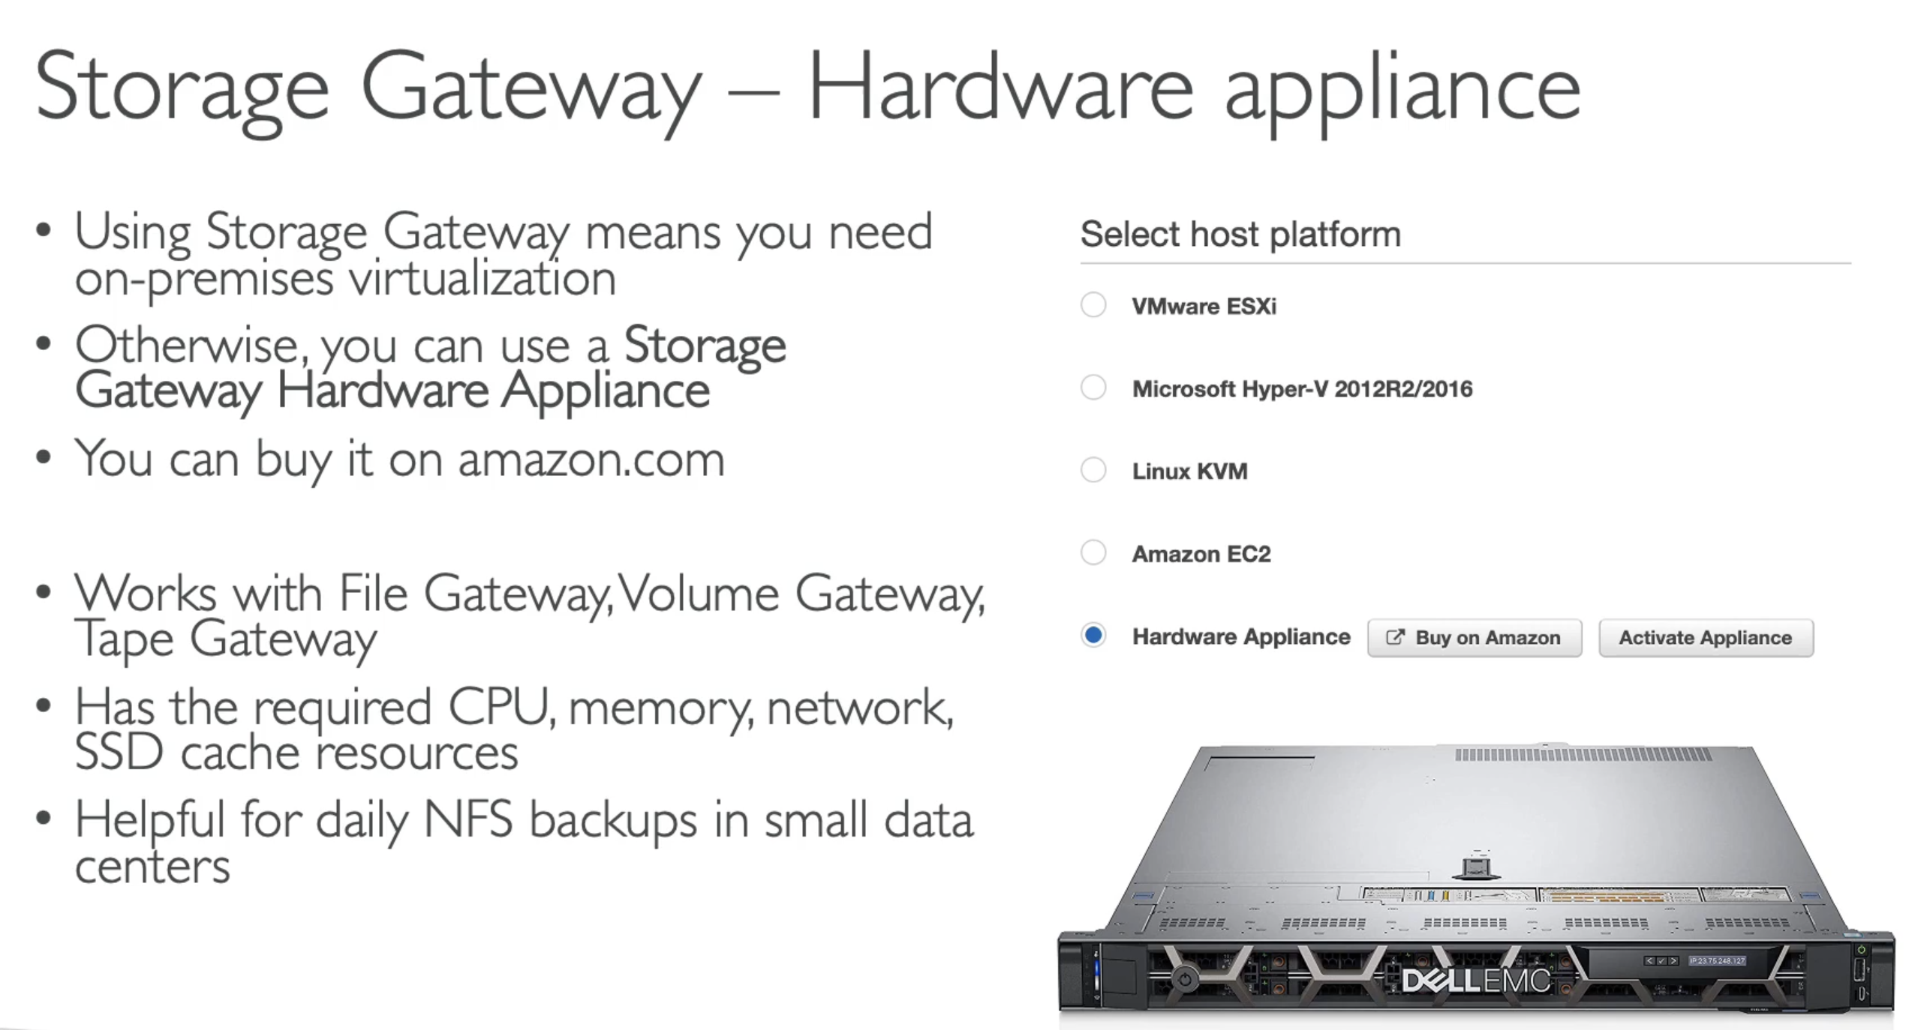

### ExamTip:

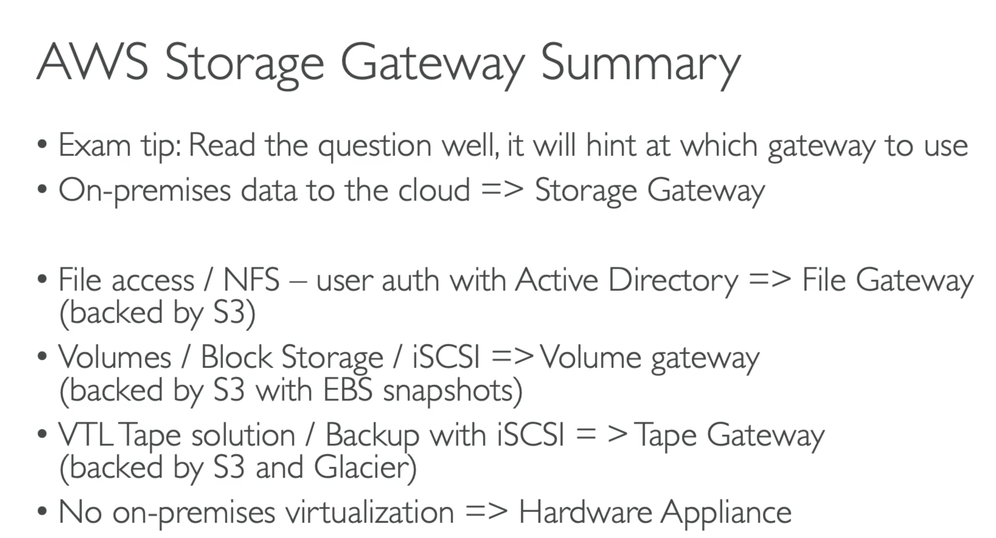

## 151. Amazon FSx – Overview

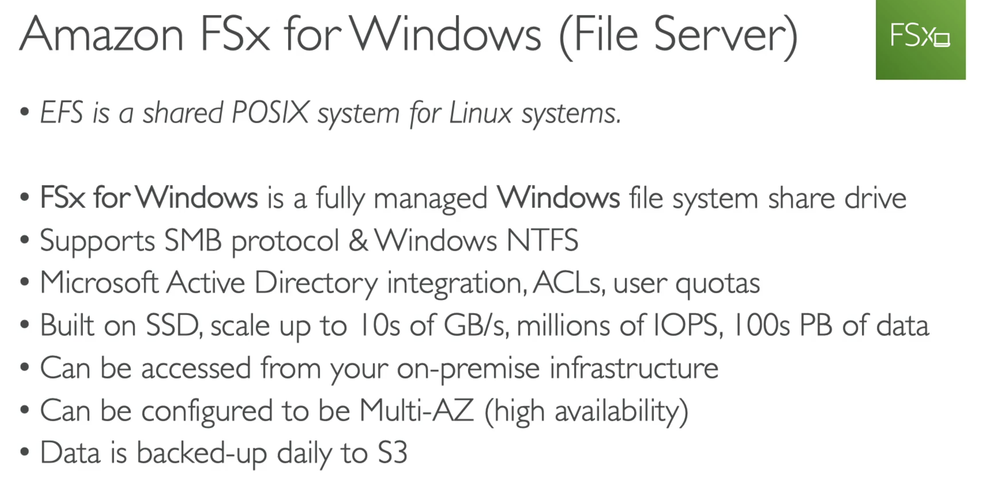

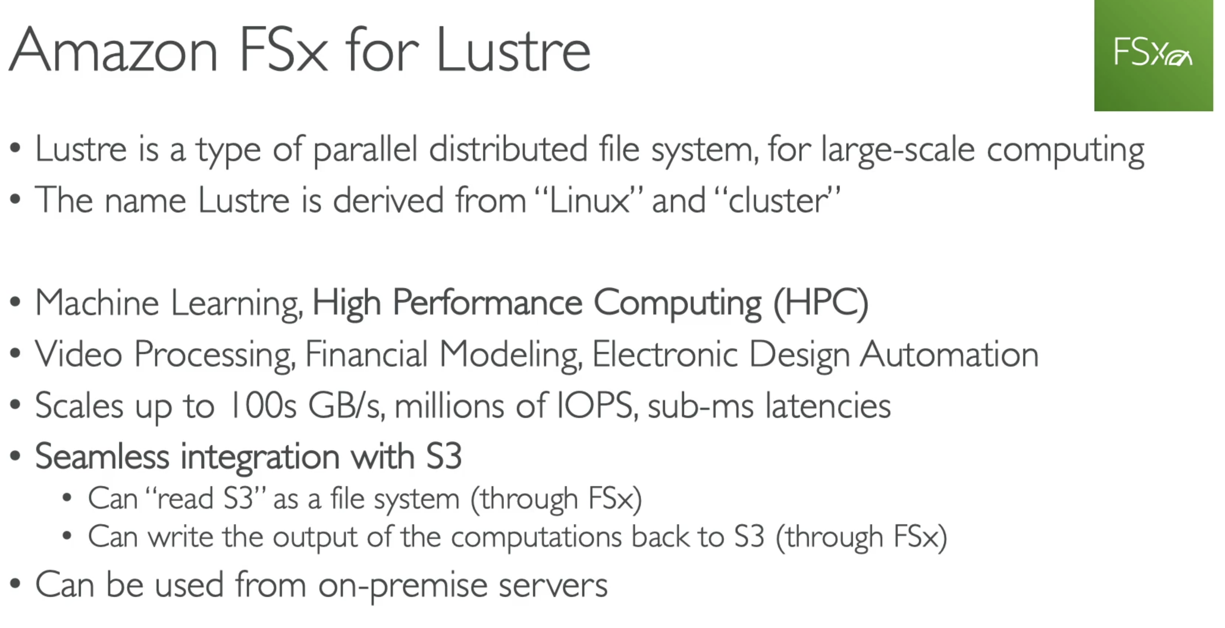

## 153. All AWS Storage Options Compared

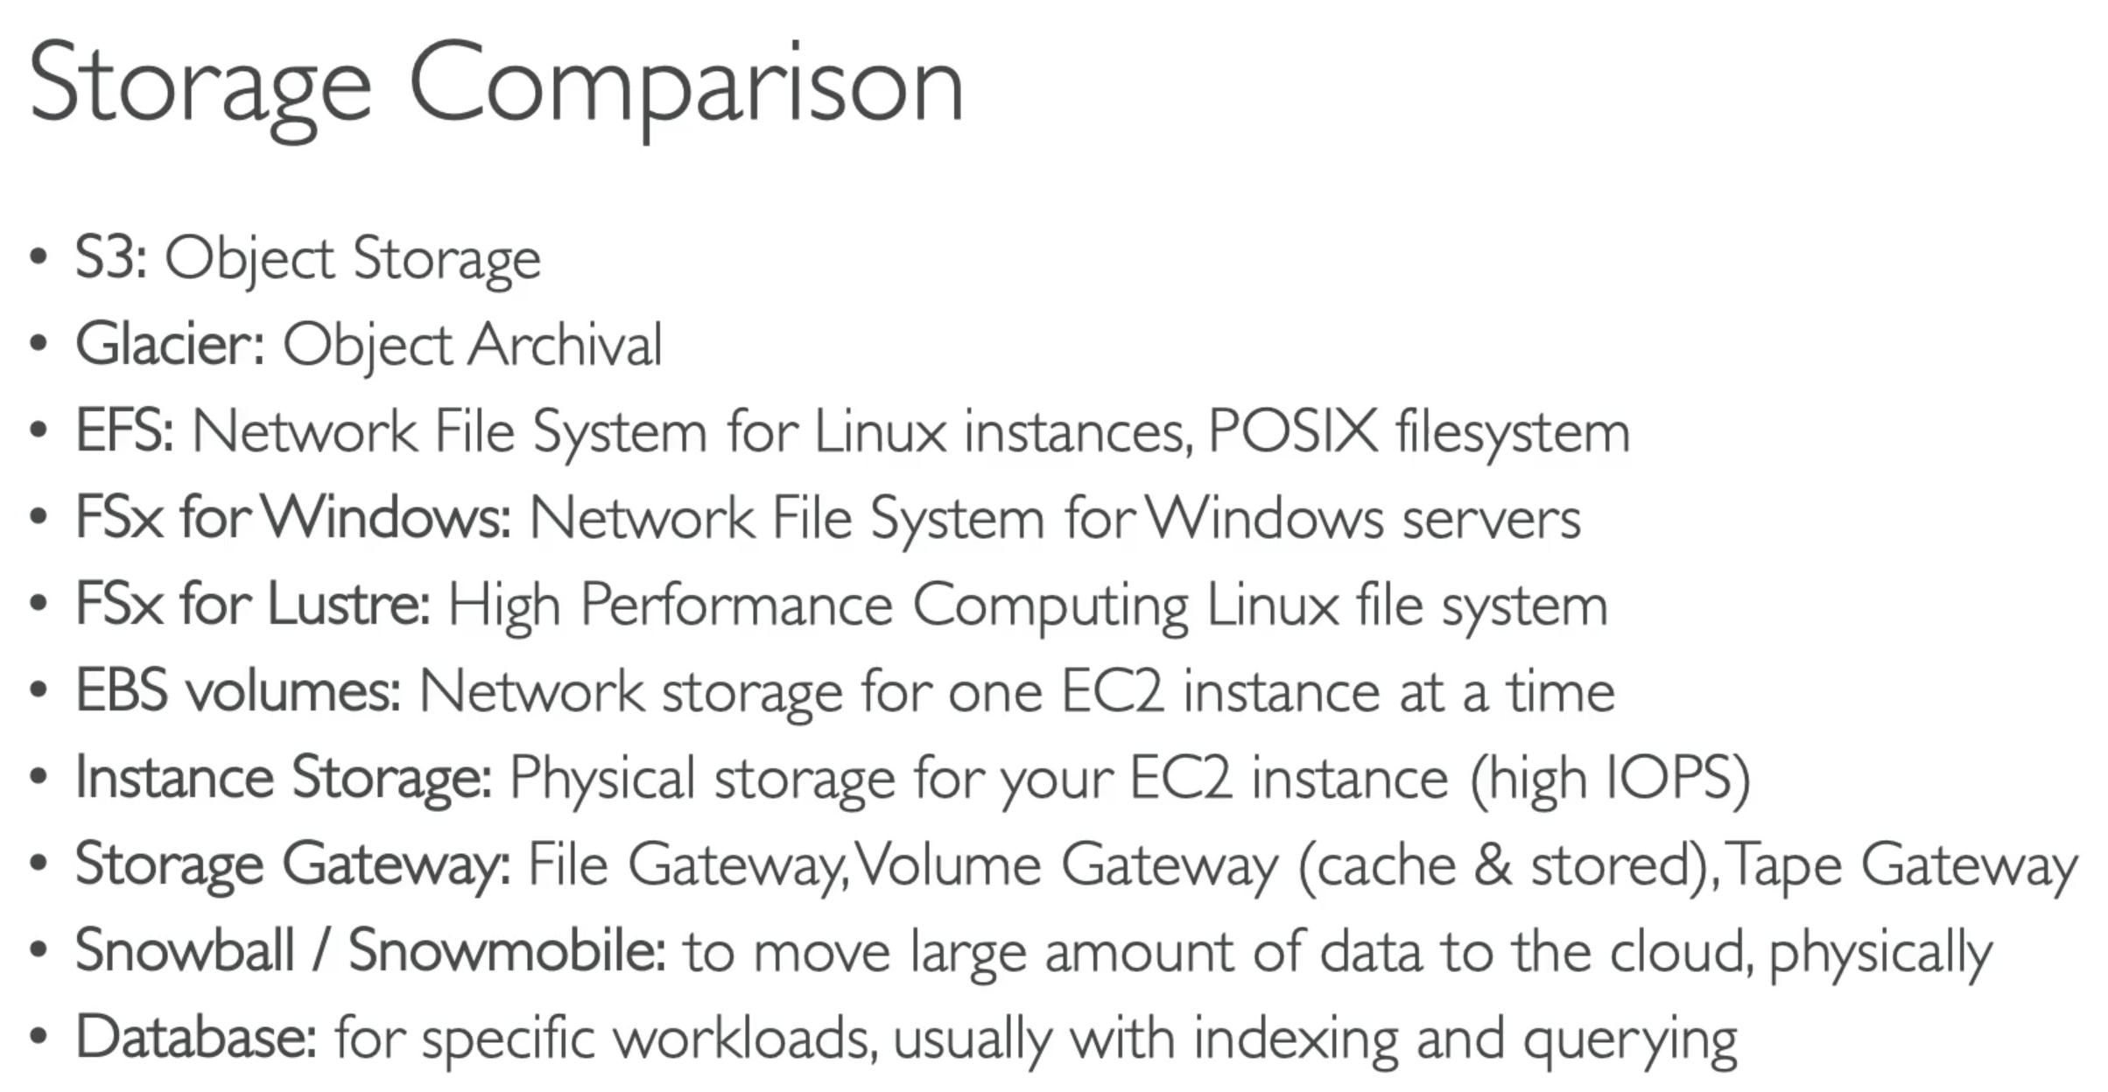

Snow-cone: 8TB of usable storage, used for edge computing, storage, and data transfer